Mediclinic Rooftop PV Projects: Performance Report

Prepared for:

Moshesh Partners

Reference No:

HAR_215_Moshesh Mediclinic Monthly Performance Report

February 2023

Document Control

|  |  |  |  |
| --- | --- | --- | --- |
| **Responsible for** | **Name** | **Date** | **Signature** |
| Content | Mutali Nepfumbada | 21 September 2022 |  |
| Checked | Thulani Ndaba | 22 September 2022 |  |
| Approved | Adam Terry | 23 September 2022 |  |
| Copyright: | Commercial in Confidence | Document Reference: | HAR_215_Moshesh Mediclinic Monthly Report |
| Signatures in this approval box have checked this document in line with quality procedures requirements  This document has been prepared by Harmattan with all reasonable skill and care. The document contains information from sources and data which we believe to be reliable, but we have not confirmed that reliability and make no representation as to their accuracy or completeness.  The document is confidential to the Client and Harmattan accepts no responsibility to any third party to whom information in this proposal may be disclosed. No part of this document may be reproduced without the prior written approval of Harmattan. | | | |

Table of Contents

1. Portfolio Overview 5

1.1. Scope of Work 5

1.2. Site Visits 5

1.3. Report Layout and Risk Assessment Scale 5

2. Executive Summary 1

2.1. Performance Summary 1

2.2. Key Risks, Recommendations & Actions 1

3. Revenue 3

3.1. Revenues 3

4. Highveld Technical Performance 5

4.1. Highveld Production Vs Forecast 5

4.2. Highveld Irradiation Vs Forecast 6

4.3. Highveld Availability Vs Forecast 7

4.4. Highveld Performance Ratio Vs Forecast 7

5. Durbanville Technical Performance 9

5.1. Durbanville Production Vs Forecast 9

5.2. Durbanville Irradiation Vs Forecast 11

5.3. Durbanville Availability Vs Forecast 12

5.4. Durbanville Performance Ratio Vs Forecast 12

6. Midstream Technical Performance 14

6.1. Midstream Production Vs Forecast 14

6.2. Midstream Irradiation Vs Forecast 16

6.3. Midstream Availability Vs Forecast 16

6.4. Midstream Performance Ratio Vs Forecast 17

7. Hermanus Technical Performance 18

7.1. Hermanus Production Vs Forecast 18

7.2. Hermanus Irradiation Vs Forecast 20

7.3. Hermanus Availability Vs Forecast 20

7.4. Hermanus Performance Ratio Vs Forecast 21

8. Vergelegen Technical Performance 22

8.1. Vergelegen Production Vs Forecast 22

8.2. Vergelegen Irradiation Vs Forecast 24

8.3. Vergelegen Availability Vs Forecast 24

8.4. Vergelegen Performance Ratio Vs Forecast 25

9. Events 26

9.1. Health and Safety 26

9.2. Scheduled Maintenance 26

9.3. Unscheduled Maintenance 26

9.4. Spare Parts 27

10. Project Budget 28

11. Documents Reviewed 29

List of Figure

Figure 2‑1: Project Locations 1

Figure 3‑1: Revenue to Date 2

Figure 4‑2: Highveld Irradiation Vs Forecast 4

Figure 4‑3: Highveld Availability Vs Forecast 5

Figure 4‑4: Highveld PR Vs Forecast 5

Figure 4‑1: Hermanus Production Vs Forecast 6

Figure 5‑4: Durbanville Irradiation Vs Forecast 7

Figure 5‑5: Durbanville Availability Vs Forecast 8

Figure 5‑6: Durbanville PR Vs Forecast 8

Figure 5‑1: Durbanville Production Vs Forecas 9

Figure 6‑2: Midstream Irradiation Vs Forecast 10

Figure 6‑3: Midstream Availability Vs Forecast 11

Figure 6‑4: Midstream PR Vs Forecast 11

Figure 6‑1: Midstream Production Vs Forecast 12

Figure 7‑3: Hermanus Irradiation Vs Forecast 13

Figure 7‑4: Hermanus Availability Vs Forecast 14

Figure 7‑5: Hermanus PR Vs Forecast 15

Figure 7‑1: Hermanus Production Vs Forecast 15

Figure 8‑3: Vergelegen Irradiation Vs Forecast 17

Figure 8‑4: Vergelegen Availability Vs Forecast 17

Figure 8‑5: Vergelegen PR Vs Forecast 18

Figure 8‑1: Vergelegen Production Vs Forecast 18

Figure 8‑2: Vergelegen Production Vs Forecast 18

Figure 8‑3: Tzaneen Irradiation Vs Forecast 21

Figure 8‑4: Tzaneen Availability Vs Forecast 21

Figure 8‑5: Tzaneen PR Vs Forecast 22

Figure 8‑1: Tzaneen Production Vs Forecast 22

List of Table

Table 1‑2: Risk Definitions Key 6

Table 2‑1: Project Overview 1

*Table 4‑1: PPA Rates* 2

Table 3‑2: Project Revenue Overview 2

Table 4‑1: Highveld Project Overview 4

Table 4‑3: Highveld irradiation and Forecast 4

Table 4‑4: Highveld Availability and Forecast 5

Table 4‑5: Highveld PR and Forecast 5

Table 4‑2: Hermanus Production and Forecast 6

Table 5‑1: Durbanville Project Overview 7

Table 5‑3: Durbanville irradiation and Forecast 7

Table 5‑4: Durbanville Availability and Guaranteed 8

Table 5‑5: Durbanville PR and Forecast 8

Table 5‑2: Durbanville Production and Forecast 9

Table 6‑1: Midstream Project Overview 10

Table 6‑3: Midstream Irradiation and Forecast 10

Table 6‑4: Midstream Availability and Guaranteed 11

Table 6‑5: Midstream PR and Forecast 11

Table 6‑2: Midstream Production and Forecast 12

Table 7‑1: Hermanus Project Overview 13

Table 7‑3: Hermanus irradiation and Forecast 13

Table 7‑4: Hermanus Availability and Forecast 14

Table 7‑5: Hermanus PR and Forecast 15

Table 7‑2: Hermanus Production and Forecast 15

Table 8‑1: Vergelegen Project Overview 16

Table 8‑3: Vergelegen irradiation and Forecast 17

Table 8‑4: Vergelegen Availability and Guaranteed 17

Table 8‑5: Vergelegen PR and Forecast 18

Table 8‑2: Vergelegen Production and Forecast 18

Table 8‑1: Tzaneen Project Overview 20

Table 8‑3: Tzaneen irradiation and Forecast 21

Table 8‑4: Tzaneen Availability and Guaranteed 21

Table 8‑5: Tzaneen PR and Forecast 22

Table 8‑2: Tzaneen Production and Forecast 22

Table 9‑1: Unscheduled Maintenance Events 23

Abbreviations

|  |  |
| --- | --- |
| COD | Commercial Operating Date |
| HSE | Health and Safety and Environment |
| kWh | Kilo Watt Hour |
| OPEX | Operating expenses |
| PPA | Power Purchase Agreement |
| PR | Performance ratio |
| SCADA | Supervisory control and data acquisition |
| YTD | Year-to-date |

Glossary of Terms

|  |  |
| --- | --- |
| Actual Production | Production produced in kWh |
| Predicted Production | The forecasted P50 production in kWh |
| PR | Actual production divided by weather adjusted production in % |
| Weather Adjusted Predicted | Predicted production adjusted for actual weather in kWh |

# Introduction

Harmattan Renewables (Harmattan) has been appointed by Moshesh Partners (the Client) to provide asset management support for its rooftop PV assets at various Mediclinic sites across South Africa. The projects were all installed by ACES Africa (ACES) who are now acting as the O&M contractor.

## Scope of Work

The scope of work is fully described in Harmattan proposal “*HAR_P215_MOSHESH_MediclinicAssetManagement _v2”*, dated 15 July 2022”.

## Site Visits

Harmattan has conducted 6 month operational site visits to Vergelegen, Midstream and Durbanville and the reports are Appendices to this document. The next site visit will be conducted to Hermanus and the Highveld upon confirmation of dates with the contractor.

## Report Layout and Risk Assessment Scale

Key findings and recommendations to the Client are highlighted in a summary table at section 2 of the report The table is colour coded and includes a narrative summary of the overall findings. A detailed summary of the documents reviewed is included in section 9 of the report. Where possible, Harmattan will confirm whether review items are consistent with market norms / standards and across all Project documentation. Where Harmattan identifies an omission, error, inconsistency, or deviation from our expectations, an issue will be flagged, analysed, and assigned a risk rating as outlined in Table 1‑2.

For all items, where an issue is identified, a risk category and colour code are allocated. Categorisation is achieved by making a qualitative assessment of the probability of the occurrence of the issue and the severity of the impact of the issue and allocating a tag Critical (C) / High (H) / Medium (M) / Low (L) / Negligible (N) and associated colour code to each issue (together with a brief explanation of why the tags were chosen). These tags are then multiplied in a range of combinations to yield a qualitative risk categorisation (see graphic below). This categorisation of risk allows for the prioritisation of the issues originally identified and brings a degree of focus to the subsequent mitigation process. If no risk is present / relevant, then the categorisation is summarised as 'Not Applicable' (N/A). Harmattan highlights that a simple, non-numerical, approach has been adopted to maintain the simplicity and functionality of the method and to avoid unproductive debates around the calibration of the categorisation components.

|  |  |  |
| --- | --- | --- |
| **Key** | **Definition** | **Description** |
| **C** | **Critical** | Risk of critical negative influence on project/investment outcome |
| **H** | **High** | Risk of high negative influence on project/investment outcome |
| **M** | **Medium** | Risk of medium negative influence on project/investment outcome. |
| **L** | **Low** | Risk of low negative influence on project/investment outcome. |
| **N** | **Negligible** | Risk of negligible negative influence on project/investment outcome. |
| **N/A** | **Not Applicable** | No risk present/relevant. |
| **TBC** | **Awaiting**  **Information** | Additional information required to enable Harmattan to opine on the risk. |

Table 1‑2: Risk Definitions Key

# Executive Summary

## Portfolio Overview

The following map shows the location of Moshesh Rooftop PV Portfolio operating sites. The sites are in the Gauteng and Western Cape Provinces of South Africa.

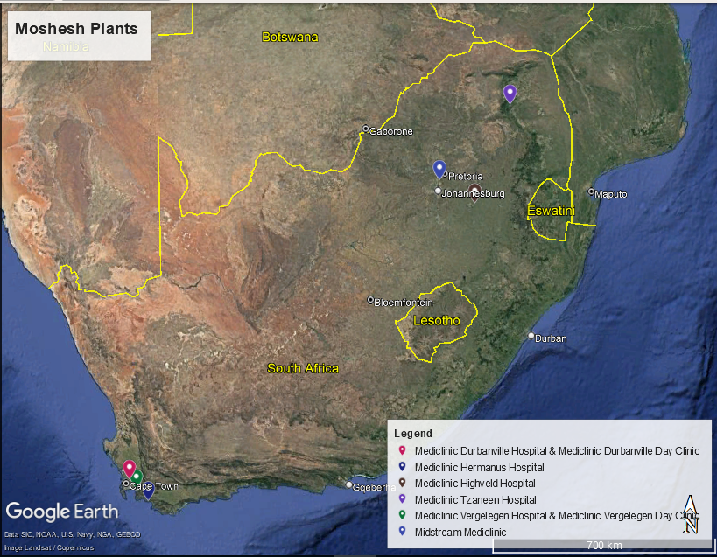

Figure 2‑1: Project Locations

|  |  |  |  |
| --- | --- | --- | --- |
| **Name** | **COD (Commercial Operation Date)** | **Design Capacity DC/AC (kW)** | **Installed**  **Capacity DC/AC (kW)** |
| Moshesh Mediclinic Durbanville Solar PV (“Durbanville”) | 11 November 2021 | 704.6 / 650 | 705.7 / 650 |
| Moshesh Mediclinic Hermanus Solar PV (“Hermanus”) | 10 March 2022 | 211.7 / 200 | 211.7 / 220 |
| Moshesh Mediclinic Highveld Solar PV (“Highveld”) | 30 March 2022 | 263 / 250 | 258.9 / 250 |
| Moshesh Mediclinic Midstream Solar PV (“Midstream”) | 27 October 2021 | 227.9 / 200 | 227.9 / 220 |
| Moshesh Mediclinic Vergelegen Solar PV (“Vergelegen”) | 28 October 2021 | 697.1 / 650 | 689.6 / 650 |
| Moshesh Mediclinic Tzaneen Solar PV (“Tzaneen”) | 11 october 2022 | 405/350 | 405/350 |

Table 2‑1: Project Overview

## Performance Summary

The following section describes August 2022 performance of the sites.

* + - 1. Moshesh Mediclinic Vergelegen Solar PV
* Production is 203,236 kWh with a variance of 55.17 % below the P50 forecast.
* Irradiation is 247 kWh/m2 with a variance of -1.77 % below P50 forecast.
* Availability is 84% with a variance of -10.71 % above the warranted availability.
* PR is 94 % with a variance of 25.78 % below warranted availability.
* Revenue is R152,314 with a variance of 55.17 % below forecast.
  + 1. Moshesh Mediclinic Durbanville Solar PV
* Production is 79,512 KWh with a variance of -37.72 % below the P50 forecast.
* Irradiation is 260 kWh/m2 with a variance of 1.98 % below P50 forecast.
* Availability is 77 % with a variance of -19.06 % above the warranted availability.
* PR is 60 % with a variance of 60 % below warranted availability.
* Revenue is R58,795 with a variance of -37.72 % below forecast.
  + 1. Moshesh Mediclinic Midstream Solar PV
* Production is 30,813 kWh with a variance of -13.07 % below the P50 forecast.
* Irradiation is 231 kWh/m2 with a variance of 12.39 % below P50 forecast.
* Availability is 83 % with a variance of -12.62 % above the warranted availability.
* PR is 78 % with a variance of 0.57 % below warranted availability.
* Revenue is R25,320 with a variance of -13.07 % below forecast.
  + 1. Moshesh Mediclinic Hermanus Solar PV
* Production is 30,525 kWh with a variance of -28.35 % below the P50 forecast.
* Irradiation is 223 kWh/m2 with a variance of -6.32 % below P50 forecast.
* Availability is 73 % with a variance of -23.17 % above the warranted availability.
* PR is 64 % with a variance of -22.1 % below warranted availability.
* Revenue is R27,886 with a variance of -28.35 % below forecast.
  + 1. Moshesh Mediclinic Highveld Solar PV
* Production is 32,109 kWh with a variance of -21.68 % below the P50 forecast.
* Irradiation is 231 kWh/m2 with a variance of 12.64 % below P50 forecast.
* Availability is 74 % with a variance of -21.95 % above the warranted availability.
* PR is 72 % with a variance of -5.18 % below warranted availability.
* Revenue is R24,330 with a variance of -21.68 % below forecast.
  + 1. Moshesh Mediclinic Tzaneen Solar PV
* Production is 44,182 kWh with a variance of -22.27 % below the P50 forecast.
* Irradiation is 197 kWh/m2 with a variance of 13.57 % below P50 forecast.
* Availability is 0 % with a variance of -100.0 % above the warranted availability.
* PR is 70 % with a variance of -15.86 % below warranted availability.
* Revenue is R40,312 with a variance of -22.27 % below forecast.

## Key Risks, Recommendations & Actions

|  |  |  |  |
| --- | --- | --- | --- |
| **Key Risks** | **Description** | **Risk Rating** | **Recommendations** |
| Portofilo Key risk |  |  |  |
| Vergelegen  Technical Risk |  |  |  |
| Midstream  Technical Risk |  |  |  |
| Durbanville  Technical Risk |  |  |  |
| Performance Guarantee |  |  |  |
| Major Spare parts |  |  |  |

Table 2‑2: Key Risks

# O&M Contract

Harmattan notes that the O&M contract between Moshesh and ACES Africa (Operator) has not yet been signed. This poses a risk to Moshesh as it is unable to claim the penalties for underperformance set forth in the contract. Harmattan notes that the Operator submits monthly reports and conducts semi-annual maintenance inspections as specified in the draft O&M contract.

# Portfolio Revenue

* 1. PPA Rates

Revenues are based on actual production and the rate agreed upon between each Mediclinic site and Moshesh under the Power Purchase Agreements (PPA) as described in Table 3-1 below.

|  |  |  |
| --- | --- | --- |
| **Plant** | **PPA Rate (ZAR/kWh)** | **Applicable Year** |
| Durbanville | 0.6423 | 11 November 2021 - 10 November 2022 |
| Vergelegen | 0.6517 | 28 October 2021 - 27 October 2022 |
| Highveld | 0.6589 | 30 March 2022 -29 March 2023 |
| Midstream | 0.7145 | 27 October 2021 - 26 October 2022 |
| Hermanus | 0.7944 | 10 March 2022 - 9 March 2023 |
| Tzaneen | 0.7934 | 11 October 2023 - 10 October2023 |

*Table 4‑1: PPA Rates*

The Moshesh/Mediclinic PPA rates increase by 6% every 12 months from COD.

Forecast revenues are based on the P50 Helioscope simulation performed during the pre-construction phase and have not been adjusted to reflect actual irradiation or the installed capacity.

Actual revenue is based upon production as recorded by the SCADA and the PPA rates.

## Revenue year to date

T The following graph show the energy sales in ZAR (South African Rand) for six Moshesh plants.

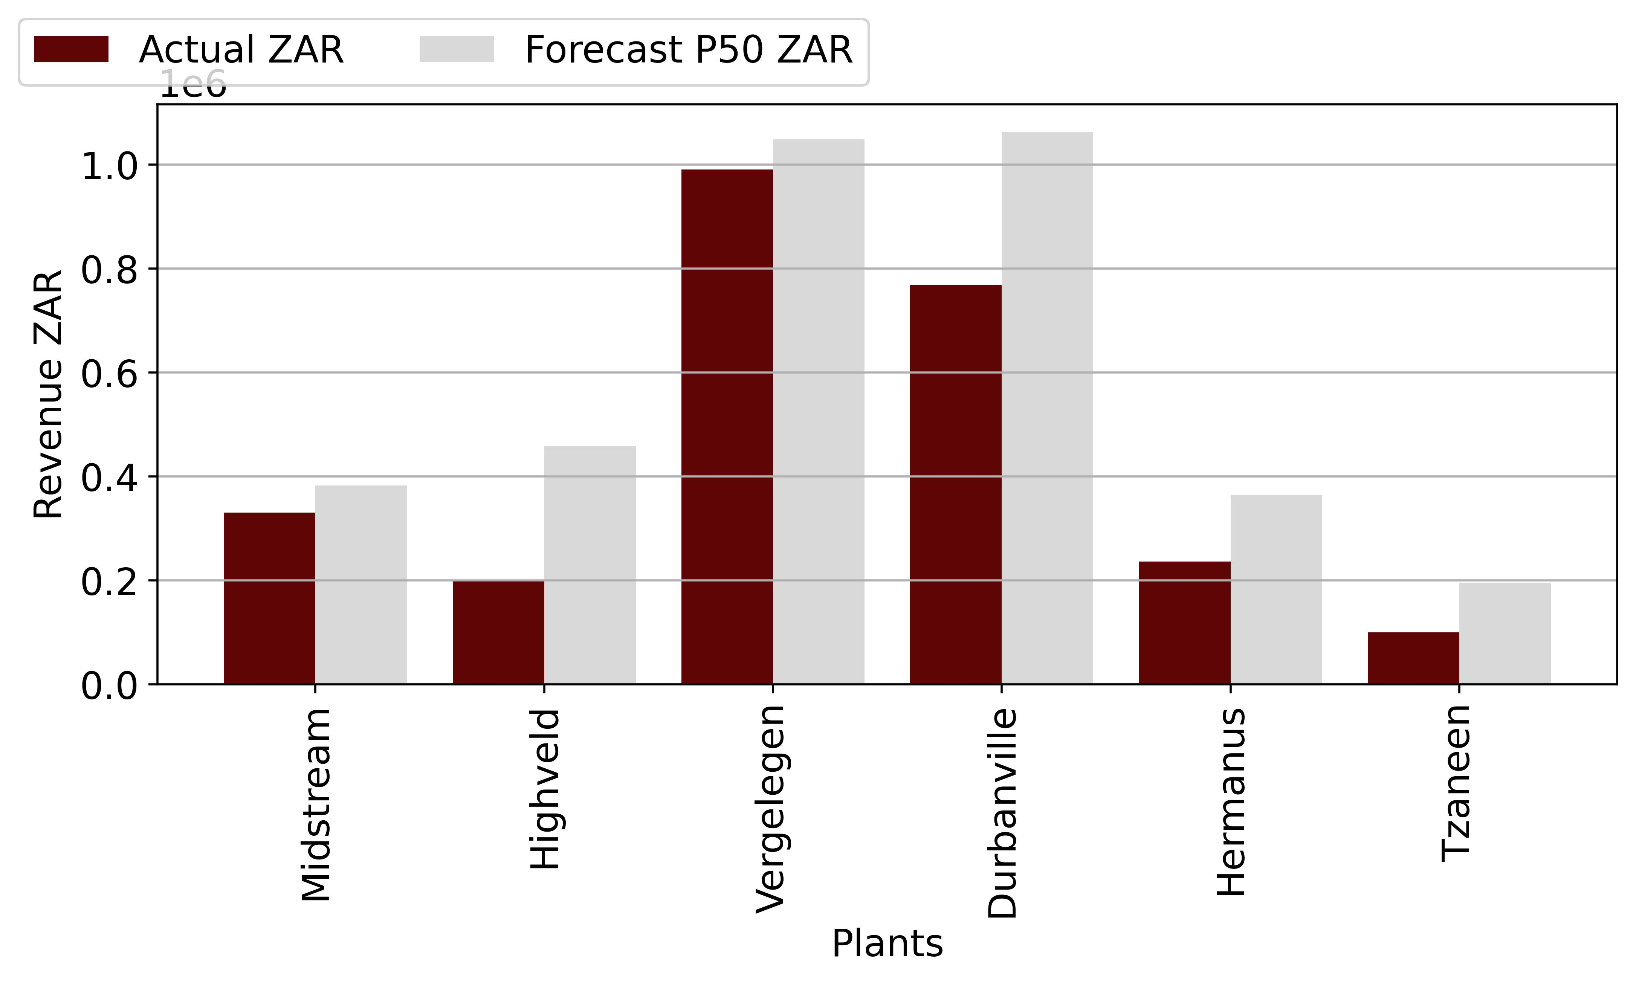

Figure 3‑1: Revenue to Date

|  |  |  |  |
| --- | --- | --- | --- |
| **Revenue (ZAR)** | | | |
| **Plants** | **Actual** | **Forecast** | **Delta (%)** |
| Durbanville | 768,268 | 1,062,930 | -27.72 |
| Vergelegen | 990,968 | 1,048,806 | -5.51 |
| Highveld | 199,991 | 457,926 | -56.33 |
| Midstream | 330,640 | 383,108 | -13.7 |
| Hermanus | 236,467 | 364,162 | -35.07 |
| Tzaneen | 100,120 | 195,909 | -48.89 |

Table 3‑2: Project Revenue Overview

We note that all the plants have been performing below the forecasted revenue, with Durbancville and Highveld showing the most significant deviation from forecast.

# Technical Portfolio Overview

We have investigated the performance of the Highveld, Durbanville, Midstream, Hermanus and Vergelegen Mediclinic solar PV sites. We evaluated performance by comparing irradiance, availability, performance ratio, and production against forecasts. All sites have underperformed against the forecast. The Operator has stated that the underperformance of each site was dominated by frequent loadshedding which has resulted in curtailment of the sites. This curtailment occurs as the installed grid tied inverters have anti -islanding protection.

Anti-islanding protection is a necessary safety feature which disables PV inverters when the grid enters an islanded condition. This means that the inverter won’t operate during a grid outage event such as Eskom load shedding. This is to protect the grid personnel working on the transmission lines during the outage. If the buildings continue to generate power during a grid outage and potentially feed power to the national grid, this could be fatal to maintenance personnel who are unaware that power is flowing in the lines when the grid is down.

An alternative to this system is to enable the PV systems to operate in an island system and so continue to supply the buildings that the PV system is connected to during time of loadshedding. Under this situation, the PV system would still generate power for direct use in the building, with no export to the external power grid. We note that that the system can only supply part of the load and it must be integrated with a generator, or battery system to allow the invertor to function.

# Highveld Technical Performance

|  |  |
| --- | --- |
| **Project Overview** | |
| Design Capacity DC/AC (kW) | 263 / 250 |
| Installed Capacity DC/AC (kW) | 258.9 / 250 |
| Technology | Solar |
| Project Company | Moshesh Solar PV 1 (Pty) Ltd |
| Address | 46 Barney Molokwane, Trichardt South Africa |
| Commercial Operation Date | 30 March 2022 |

Table 4‑1: Highveld Project Overview

## System Design

The plant is a 258.9kWp system with 540 Wp JA Solar PV modules connected to 100 kW and 50 kW Huawei inverters. The system operates by using PV modules to generate DC electricity. The DC electricity is then converted to AC electricity by the inverters for use in the buildings, offsetting the grid supply during the times when solar electricity is available. The inverters installed by Mediclinic are grid tied with anti-islanding protection. This arrangement prevents the export of power to the grid when the project is load shed.

## Data Analysed

The following sections describes the performance of the system. Harmattan compiled data from the SCADA system and reviewed the January 2023 Production report/ The Operator did not submit semi-annual reports or unscheduled maintenance reports to verify any issues that may have affected system performance. Harmattan has asked the Operator to provide this information.

The performance data was downloaded from the Higeco SCADA System and processed using Microsoft Excel. Irradiation vs Forecast.

## Irradiation vs Forecast

The following table and graph describe the irradiance of the site compared to the pre-construction Helioscope P50 prediction. Harmattan notes that the irradiance data is satellite-based.

|  |  |  |  |
| --- | --- | --- | --- |
| **Irradiation (kWh/m2)** | | | |
| **Month** | **Actual** | **Forecast** | **Delta (%)** |
| Oct 21 | 0 | 0 | 0 |
| Nov 21 | 0 | 0 | 0 |
| Dec 21 | 0 | 0 | 0 |
| Jan 22 | 0 | 205 | -100.0 |
| Feb 22 | 0 | 174 | -100.0 |
| Mar 22 | 0 | 176 | -100.0 |
| Apr 22 | 141 | 141 | 0.0 |
| May 22 | 128 | 131 | -2.48 |
| Jun 22 | 124 | 116 | 7.14 |
| Jul 22 | 128 | 128 | -0.0 |
| Aug 22 | 157 | 154 | 1.65 |
| Sep 22 | 180 | 176 | 2.3 |
| Oct 22 | 178 | 191 | -6.63 |
| Nov 22 | 167 | 197 | -15.44 |
| Dec 22 | 180 | 212 | -15.31 |
| Jan 23 | 231 | 205 | 12.64 |

Table 4‑3: Highveld irradiation and Forecast

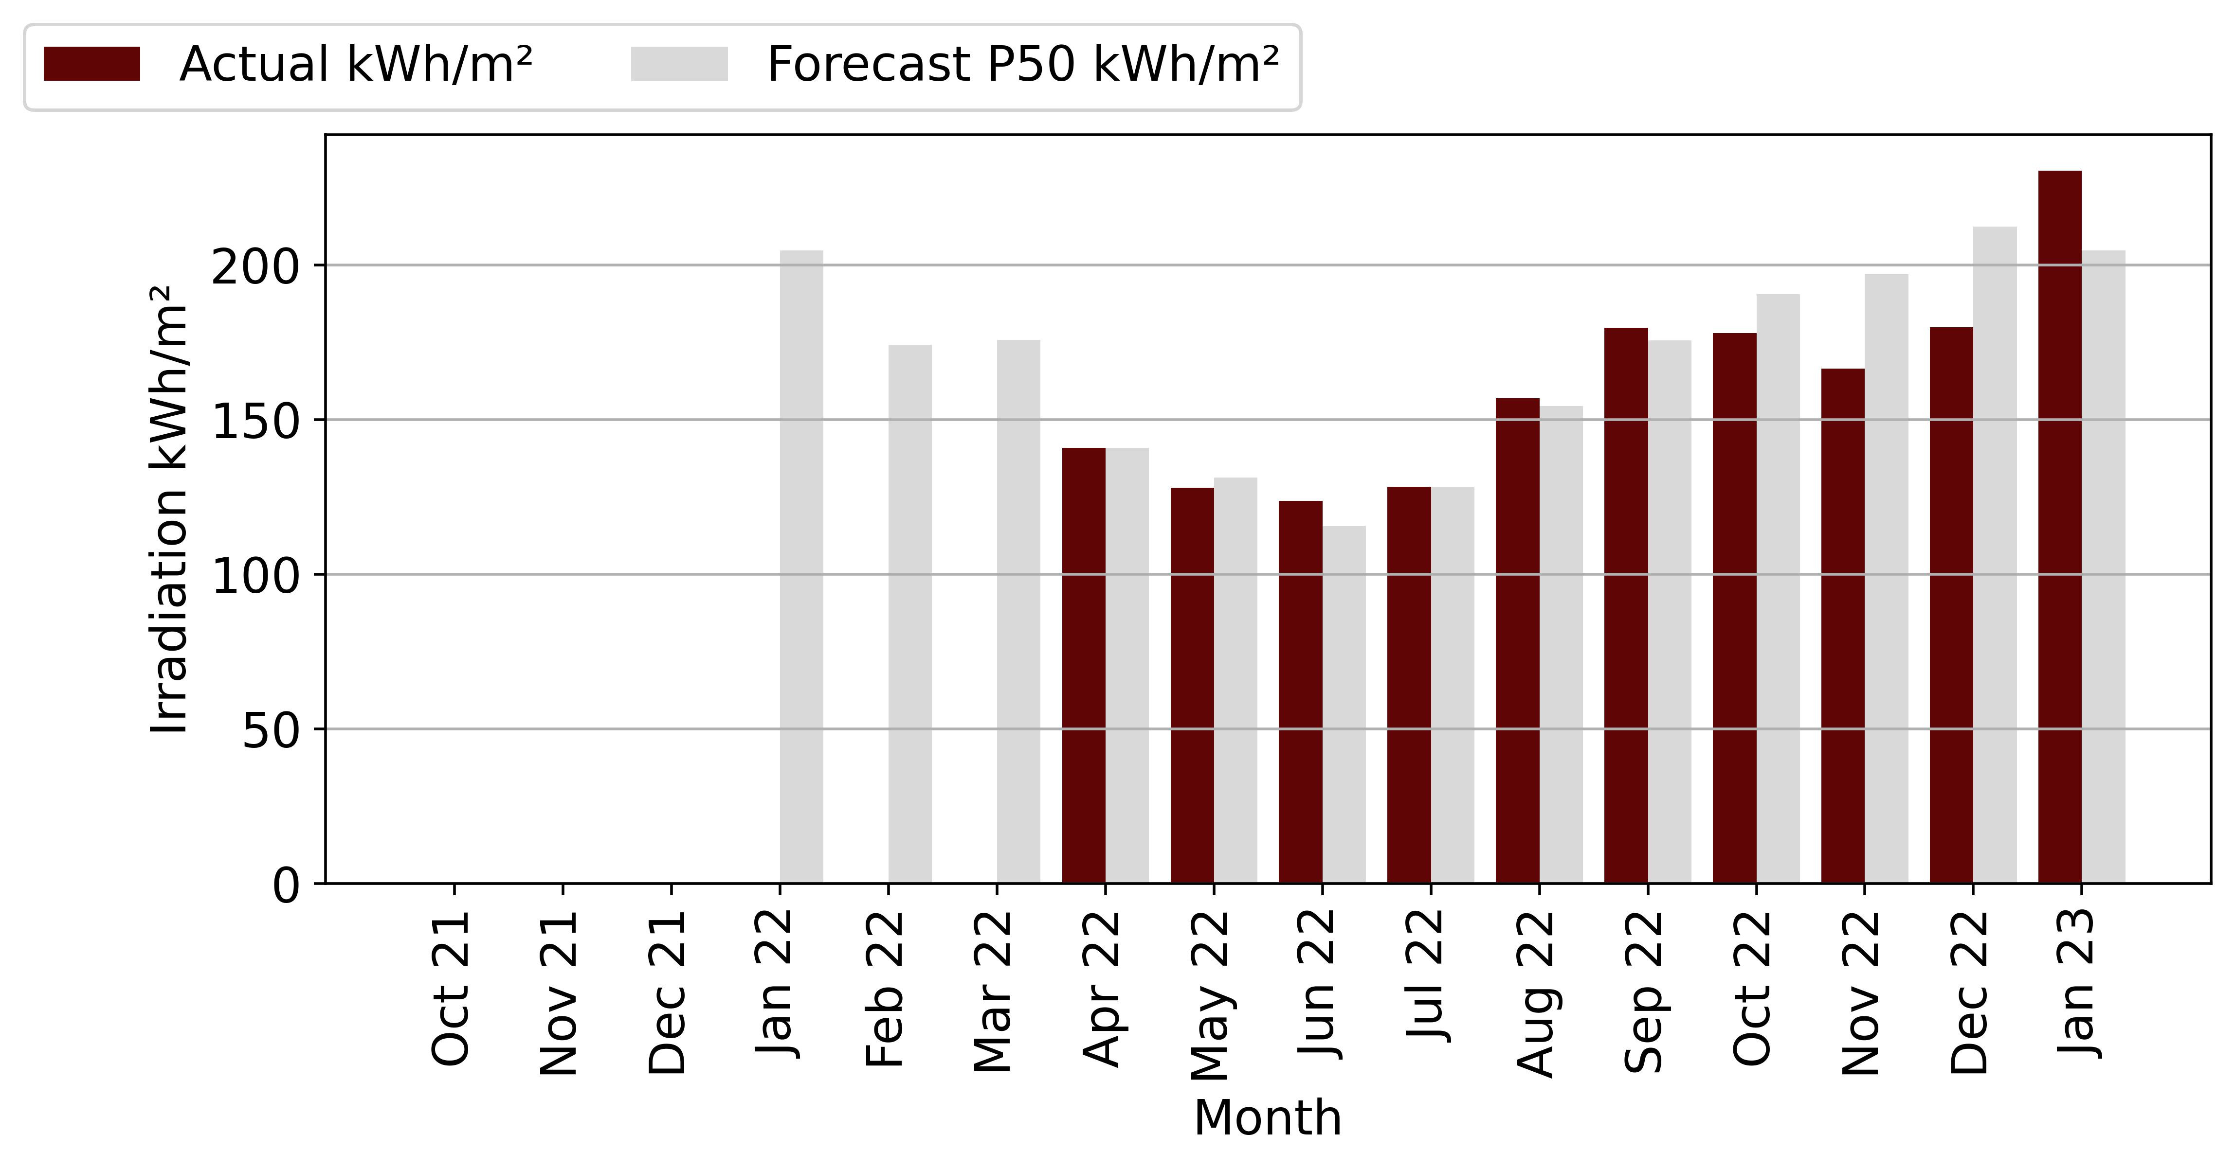

Figure 4‑2: Highveld Irradiation Vs Forecast

The table and figure above show the irradiation in kWh/m2 for January 2023. The actual irradiation was 231 kWh/m2, while the forecast was 201 kWh/m2. This represents a 14.77% difference between the actual and forecasted irradiation. Overall, the table suggests that the actual irradiation for January exceeded the forecasted value by a significant amount. This may have implications for energy production or other applications that rely on accurate irradiation predictions.

## Availability vs Forecast

The guaranteed minimum availability of the plant is 95 %.

|  |  |  |  |
| --- | --- | --- | --- |
| **Availability (%)** | | | |
| **Month** | **Actual** | **Forecast** | **Delta (%)** |
| Oct 21 | 0 | 95 | -100.0 |
| Nov 21 | 0 | 95 | -100.0 |
| Dec 21 | 0 | 95 | -100.0 |
| Jan 22 | 0 | 95 | -100.0 |
| Feb 22 | 0 | 95 | -100.0 |
| Mar 22 | 0 | 95 | -100.0 |
| Apr 22 | 95 | 95 | 0.0 |
| May 22 | 98 | 95 | 2.75 |
| Jun 22 | 95 | 95 | -0.37 |
| Jul 22 | 95 | 95 | -0.05 |
| Aug 22 | 93 | 95 | -1.78 |
| Sep 22 | 81 | 95 | -15.17 |
| Oct 22 | 88 | 95 | -7.88 |
| Nov 22 | 91 | 95 | -4.19 |
| Dec 22 | 75 | 95 | -20.55 |
| Jan 23 | 74 | 95 | -21.95 |

Table 4‑4: Highveld Availability and Forecast

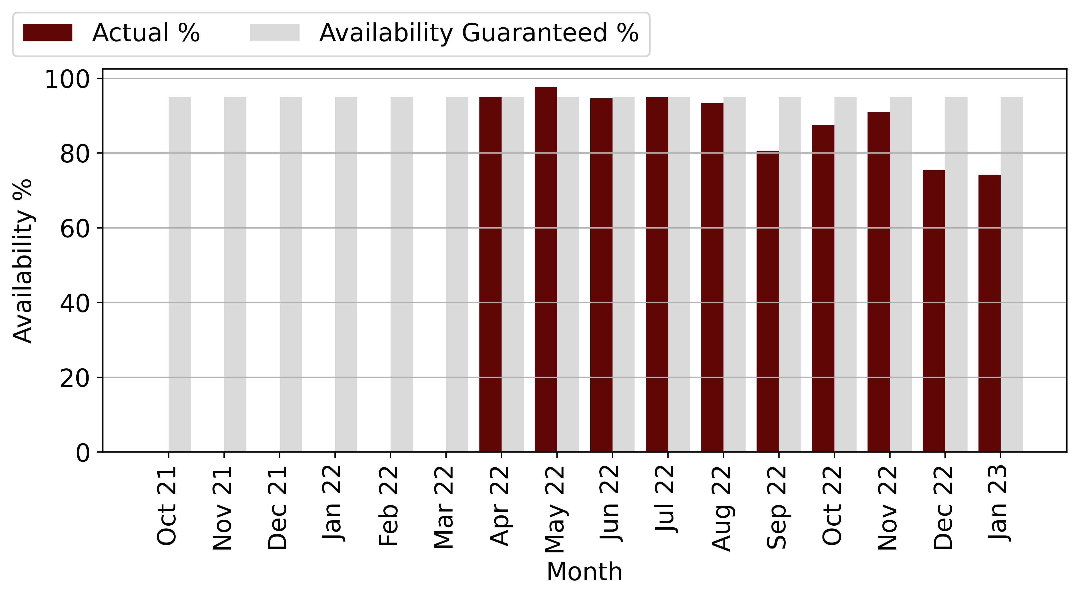

Figure 4‑3: Highveld Availability Vs Forecast

Between June and August 2022 availability has been slightly below warranted levels. The cause of this unavailability is unclear as the Operator has not submitted monthly reports.

The Operator has indicated that the availability of the power plant was mainly affected by load shedding. Harmattan recommends that the Operator submit the unscheduled maintenance reports for the site to confirm this.

## Performance Ratio vs Forecast

The following table describes the, measured performance ratio (PR) of the plants compared against the forecasted PR.

|  |  |  |  |
| --- | --- | --- | --- |
| **Performance Ratio (%)** | | | |
| **Month** | **Actual** | **Forecast** | **Delta (%)** |
| Oct 21 | 0 | 0 | 0 |
| Nov 21 | 0 | 0 | 0 |
| Dec 21 | 0 | 0 | 0 |
| Jan 22 | 0 | 0 | 0 |
| Feb 22 | 0 | 0 | 0 |
| Mar 22 | 0 | 0 | 0 |
| Apr 22 | 70 | 29 | 141.2 |
| May 22 | 67 | 73 | -8.92 |
| Jun 22 | 62 | 13 | 371.39 |
| Jul 22 | 64 | 33 | 91.75 |
| Aug 22 | 65 | 79 | -17.31 |
| Sep 22 | 52 | 79 | -34.07 |
| Oct 22 | 53 | 79 | -32.88 |
| Nov 22 | 0 | 78 | -100.0 |
| Dec 22 | 0 | 78 | -100.0 |
| Jan 23 | 72 | 76 | -5.18 |

Table 4‑5: Highveld PR and Forecast

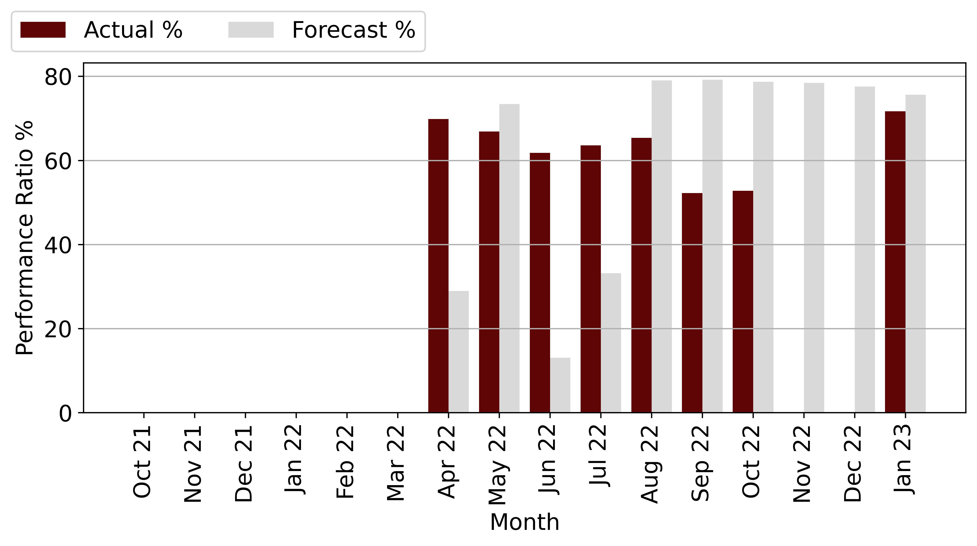

Figure 4‑4: Highveld PR Vs Forecast

In January 2023, the Performance Ratio was 72%, which was lower than the forecasted value of 76% by 5.18%. PR is below forecast due to frequent load shading event occurring across south Africa this has resulted in curtailment of the plant for 2hr- 4 hours a day depending on the Stage of loadshedding.

## Production vs Forecast

The table below shows the actual production for the month of January 2023, as well as the actual production compared to the original forecast and the weather adjusted forecast. The actual production for the month was 32,109 kWh, which is lower than both the original forecast of 39,908 kWh and the weather adjusted forecast of 45,803 kWh.

|  |  |  |  |  |  |
| --- | --- | --- | --- | --- | --- |
| **Month** | **Production (kWh)** | | | **Actual vs Original Forecast (%)** | **Actual vs Weather Adjusted Forecast (%)** |
|  | **Original Forecast** | **Weather Adjusted Forecast** | **Actual Production** |
| Oct 21 | 40,430 | 0 | 0 | 0 | 0 |
| Nov 21 | 40,365 | 0 | 0 | 0 | 0 |
| Dec 21 | 42,270 | 0 | 0 | 0 | 0 |
| Jan 22 | 40,997 | 0 | 0 | 0 | 0 |
| Feb 22 | 36,012 | 0 | 0 | 0 | 0 |
| Mar 22 | 38,134 | 0 | 0 | 0 | 0 |
| Apr 22 | 32,456 | 32,456 | 21,644 | -33.31 | -33.31 |
| May 22 | 32,046 | 31,251 | 28,195 | -12.02 | -9.78 |
| Jun 22 | 29,236 | 31,325 | 17,910 | -38.74 | -42.83 |
| Jul 22 | 32,106 | 32,106 | 21,623 | -32.65 | -32.65 |
| Aug 22 | 36,751 | 37,357 | 30,455 | -17.13 | -18.47 |
| Sep 22 | 39,471 | 40,379 | 27,097 | -31.35 | -32.89 |
| Oct 22 | 40,430 | 37,750 | 28,903 | -28.51 | -23.44 |
| Nov 22 | 40,365 | 34,133 | 29,839 | -26.08 | -12.58 |
| Dec 22 | 42,270 | 35,798 | 26,159 | -38.11 | -26.93 |
| Jan 23 | 40,997 | 46,179 | 32,109 | -21.68 | -30.47 |
| **Total** | **604,335** | **358,733** | **263,933** | **-56.33** | **-26.43** |

Table 4‑2: Hermanus Production and Forecast

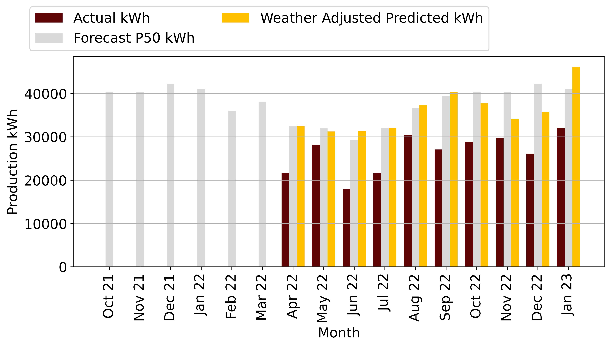

Figure 4‑1: Hermanus Production Vs Forecast

The actual production is 19.54% lower than the original forecast, which suggests that there may have been issues with the equipment

The actual production is also 29.9% lower than the weather adjusted forecast, which takes into account weather conditions that may have impacted the energy production. This suggests that the weather conditions during the month of January may have been less favourable than expected, resulting in lower energy production from the solar panels.

# 

# Durbanville Technical Performance

The following tables and figures on the technical performance and forecast data provide information on the production, irradiation, availability, and performance ratio of the plant compared to the forecast.

|  |  |
| --- | --- |
| **Project Overview** | |
| Design Capacity DC/AC (kW) | 704.6 / 650 |
| Achieved Capacity DC/AC (kW) | 705.7 / 650 |
| Technology | Solar |
| Project Company: | Moshesh Solar PV 1 (Pty) Ltd |
| Address: | Wellington Road Durbanville South Africa |
| Commercial Operation Date | 11 November 2022 |

Table 5‑1: Durbanville Project Overview

## System Design

The plant is a 705.7kWp system consisting of 535Wp JA Solar PV modules connected to 13 Huawei 50 kW inverters. The system operates by using PV modules to generate DC electricity. The DC electricity is then converted to AC electricity by the inverters for use in the buildings. The inverters installed by Mediclinic are grid tied with anti-islanding protection fitted.

## Data Analysed

The following sections describe the performance of the system. We compiled data from the SCADA system and reviewed the monthly performance report from COD through to August 2022. The Operator submitted semi-annual Checklist Reports, a Thermal Report and Unscheduled Maintenance Reports. Harmattan has used these reports together with the SCADA to analyse the performance of the system. We note that the Operator has not provided the monthly scheduled maintenance activities or a list of available spare parts.

The performance data was downloaded from the Higeco SCADA System and processed using Microsoft excel. Harmattan has reviewed the data and adjusted the incomplete months of data based on Equation 2.

## Irradiation vs Forecast

The following table and graph describe the irradiance for the month of January 2023, as well as the actual irradiation of the site compared to the Helioscope P50 prediction. Harmattan notes that the irradiance measurement is satellite-based.

|  |  |  |  |
| --- | --- | --- | --- |
| **Irradiation kWh/m2** | | | |
| **Month** | **Actual** | **Forecast** | **Delta (%)** |
| Oct 21 | 0 | 197 | -100.0 |
| Nov 21 | 152 | 231 | -34.13 |
| Dec 21 | 236 | 257 | -8.26 |
| Jan 22 | 251 | 255 | -1.79 |
| Feb 22 | 200 | 205 | -2.62 |
| Mar 22 | 180 | 189 | -4.78 |
| Apr 22 | 137 | 130 | 5.49 |
| May 22 | 93 | 94 | -0.83 |
| Jun 22 | 81 | 76 | 7.44 |
| Jul 22 | 81 | 85 | -4.98 |
| Aug 22 | 103 | 110 | -6.54 |
| Sep 22 | 137 | 149 | -7.96 |
| Oct 22 | 193 | 197 | -1.94 |
| Nov 22 | 167 | 231 | -28.03 |
| Dec 22 | 246 | 257 | -4.5 |
| Jan 23 | 260 | 255 | 1.98 |

Table 5‑3: Durbanville irradiation and Forecast

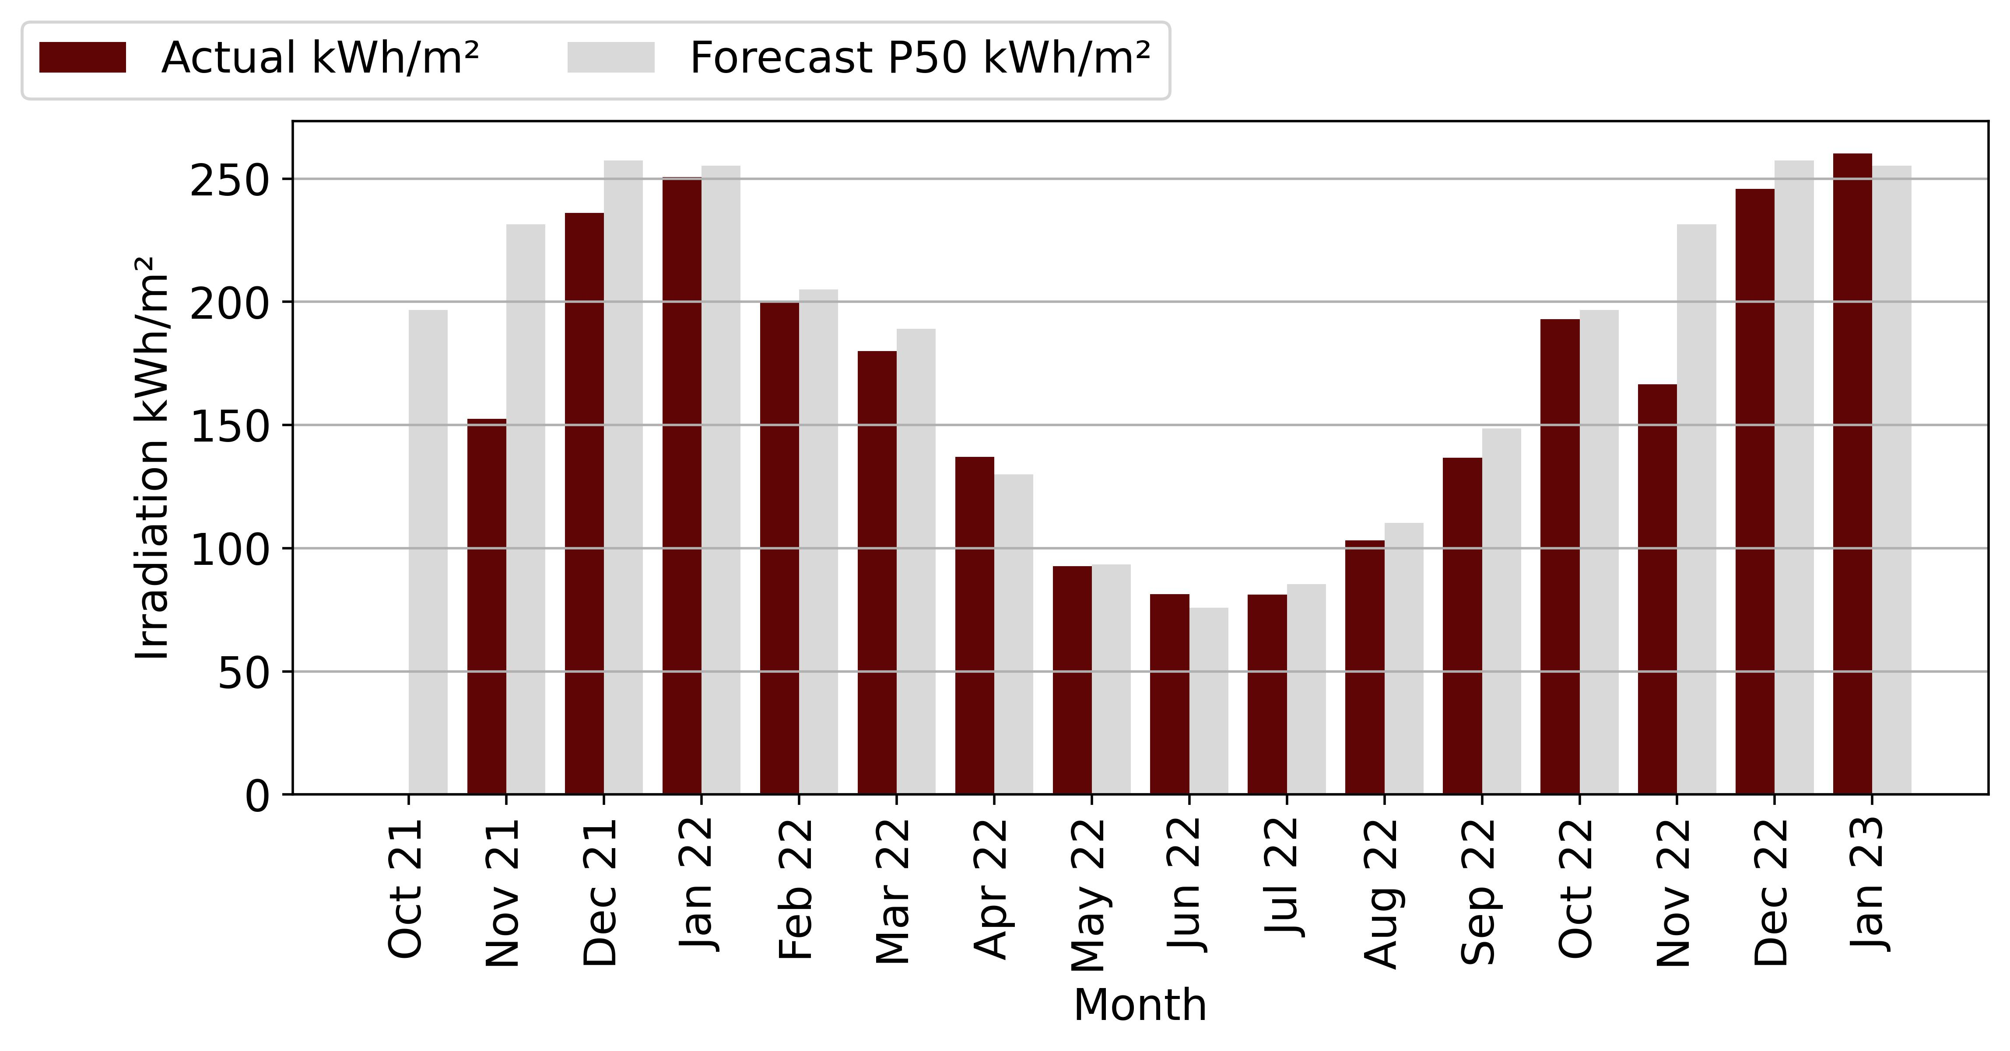

Figure 5‑4: Durbanville Irradiation Vs Forecast

The actual irradiation for the month was 260 kWh/m2, which is higher than the forecasted irradiation of 246 kWh/m2.

The percentage difference between the actual and forecasted irradiation is 5.93%, which suggests that the solar panels may have received more sunlight than expected during the month of January. This could have contributed to the higher-than-expected energy production.

It's important to note that while higher irradiation can generally lead to higher energy production, other factors such as equipment issues or shading can still impact the overall performance of the solar panel system. Therefore, it's important to conduct a comprehensive analysis of all relevant factors in order to fully understand the reasons for any discrepancies between actual and forecasted performance

## Durbanville Availability vs Forecast

The following tables and figures on the technical performance and forecast data provide information on the production, irradiation, availability, and performance ratio of the plant compared to the forecast.

|  |  |  |  |
| --- | --- | --- | --- |
| **Availability (%)** | | | |
| **Month** | **Actual** | **Forecast** | **Delta (%)** |
| Oct 21 | 0 | 0 | 0 |
| Nov 21 | 69 | 63 | 8.65 |
| Dec 21 | 100 | 95 | 5.26 |
| Jan 22 | 89 | 95 | -6.74 |
| Feb 22 | 99 | 95 | 4.26 |
| Mar 22 | 100 | 95 | 5.26 |
| Apr 22 | 97 | 95 | 1.86 |
| May 22 | 91 | 95 | -4.67 |
| Jun 22 | 95 | 95 | 0.27 |
| Jul 22 | 89 | 95 | -5.99 |
| Aug 22 | 100 | 95 | 5.0 |
| Sep 22 | 96 | 95 | 1.31 |
| Oct 22 | 96 | 95 | 1.35 |
| Nov 22 | 90 | 95 | -4.75 |
| Dec 22 | 80 | 95 | -16.13 |
| Jan 23 | 77 | 95 | -19.06 |

Table 5‑4: Durbanville Availability and Guaranteed

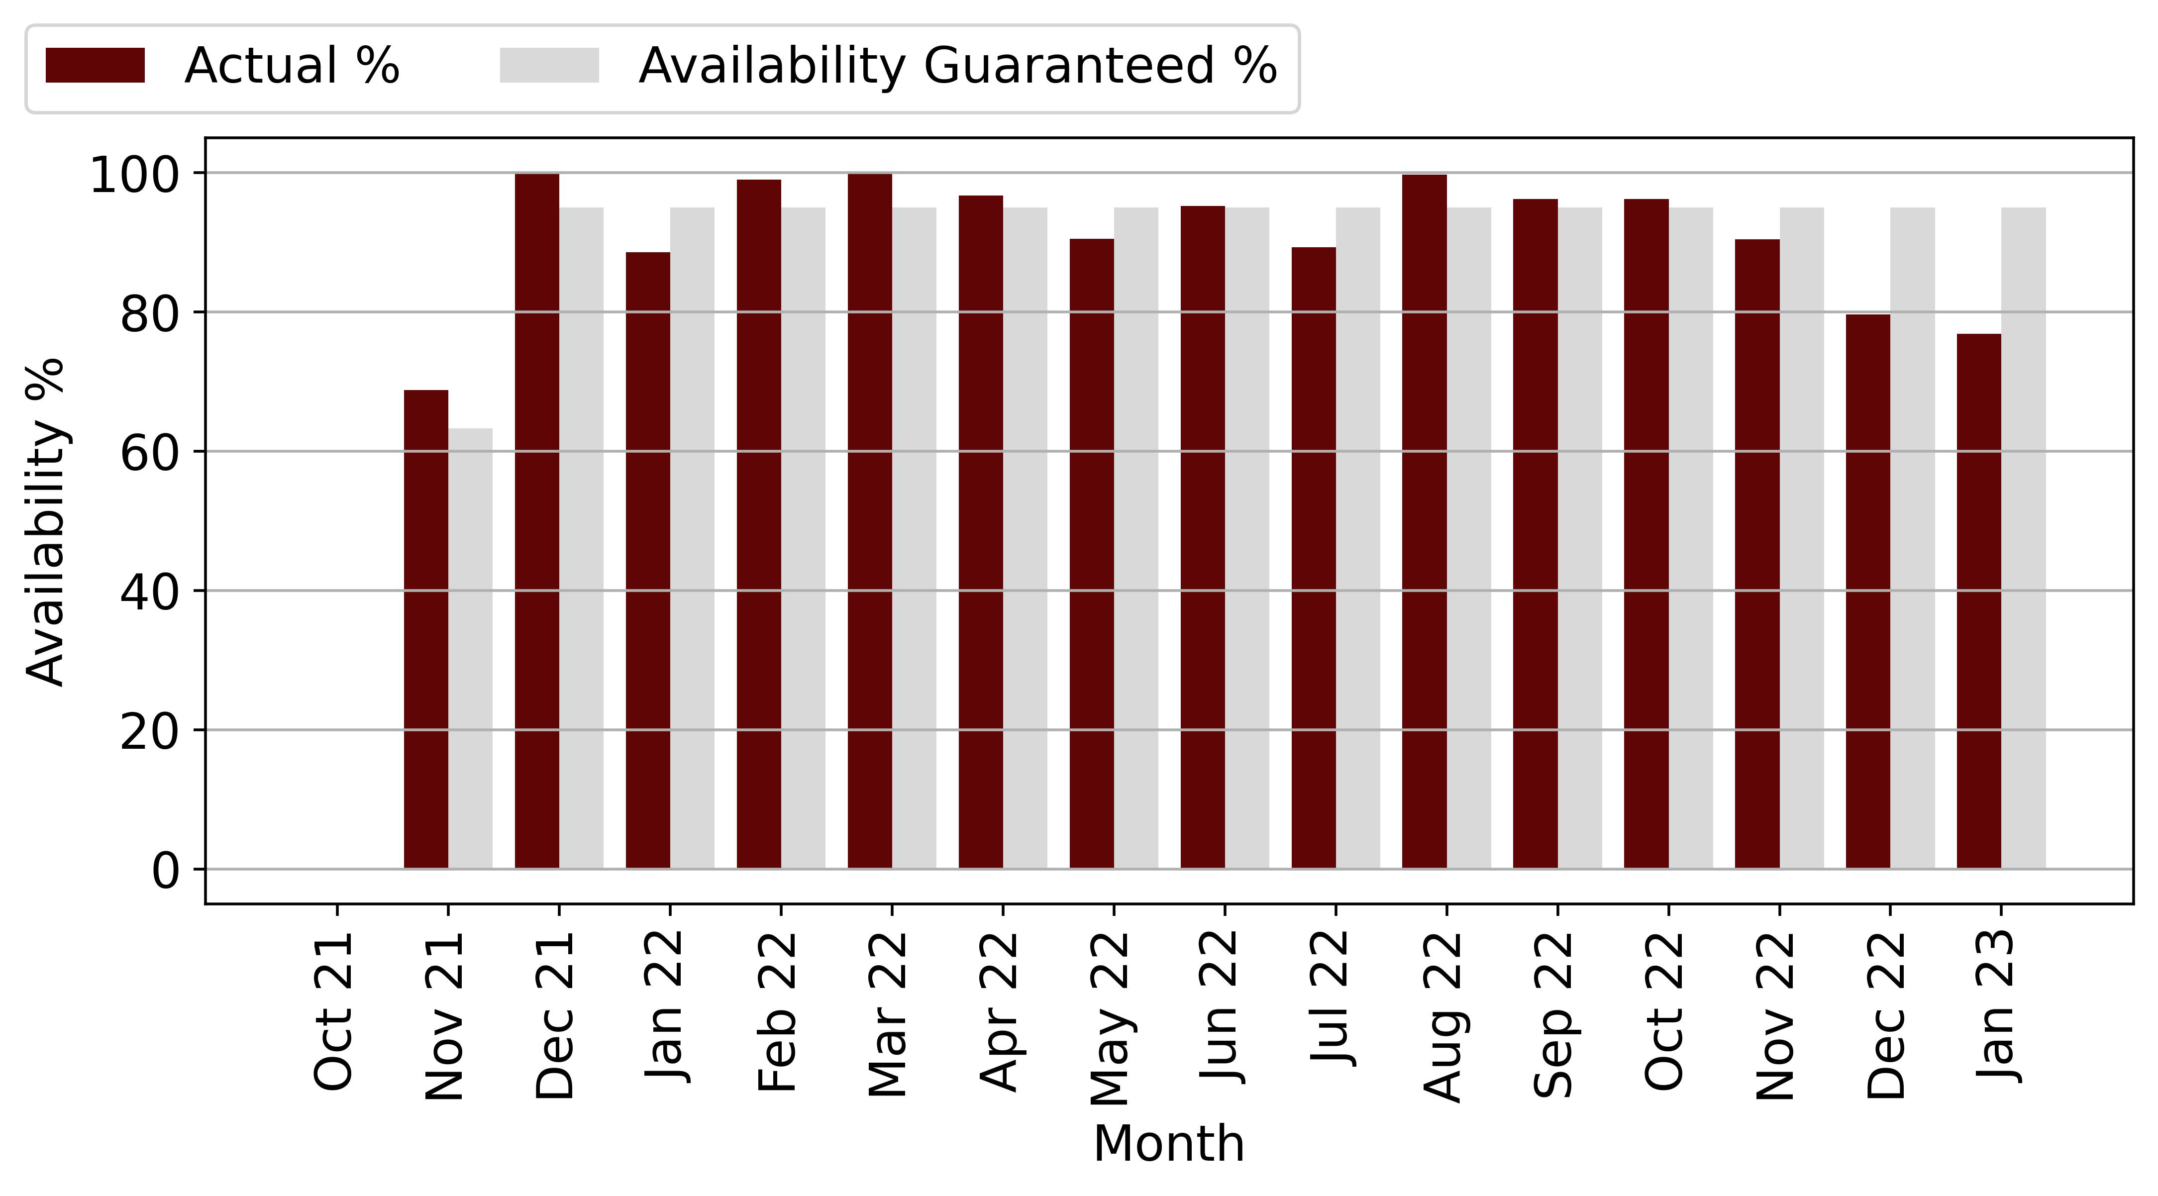

Figure 5‑5: Durbanville Availability Vs Forecast

rom the above table and diagram, we can see that the plant has reached the minimum availability of 95 % for several months since COD. We note that the plant did not reach the minimum availability in January 2022, May 2022 and July 2022 with a deviation of 4 % to 7 % from the guaranteed availability.

We also note that the plant did not meet the guaranteed availability in November 2021, but this is due to the fact that the plant was only in operation for 19 days, resulting in a misstatement of 68.81% availability.

Harmattan cannot confirm whether the power plant's unavailability was due to unscheduled maintenance, as only 3 unscheduled events were reported. The Operator has indicated that the availability of the power plant was mainly affected by load shedding. Harmattan recommends that the Operator submit the unscheduled maintenance reports for the site to confirm that the unavailability was due solely to load shedding.

## Durbanville Performance Ratio vs Forecast

The following table and chart compare the Scada Performance Ratio with the monthly forecast P50 PR of the Helioscope Forecast report.

|  |  |  |  |
| --- | --- | --- | --- |
| **Performance Ratio (%)** | | | |
| **Month** | **Actual** | **Forecast** | **Delta (%)** |
| Oct 21 | 0 | 0 | 0 |
| Nov 21 | 0 | 0 | 0 |
| Dec 21 | 0 | 0 | 0 |
| Jan 22 | 0 | 0 | 0 |
| Feb 22 | 0 | 0 | 0 |
| Mar 22 | 0 | 0 | 0 |
| Apr 22 | 60 | 62 | -3.61 |
| May 22 | 72 | 77 | -6.58 |
| Jun 22 | 67 | 80 | -16.1 |
| Jul 22 | 58 | 80 | -28.05 |
| Aug 22 | 63 | 80 | -21.88 |
| Sep 22 | 55 | 79 | -30.96 |
| Oct 22 | 52 | 78 | -33.49 |
| Nov 22 | 0 | 77 | -100.0 |
| Dec 22 | 0 | 76 | -100.0 |
| Jan 23 | 60 | 74 | -18.37 |

Table 5‑5: Durbanville PR and Forecast

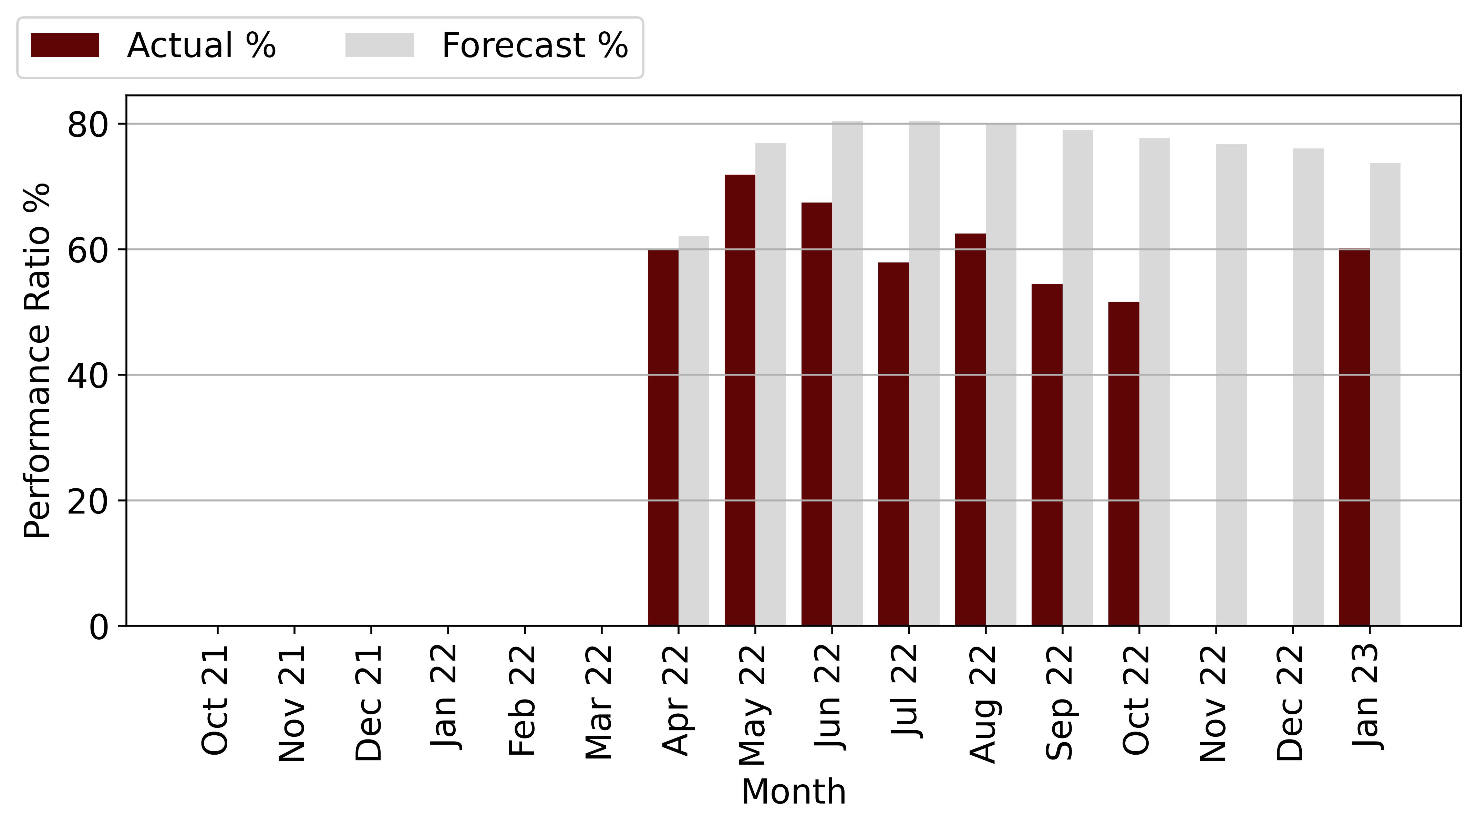

Figure 5‑6: Durbanville PR Vs Forecast

From the chart and table above, the performance ratio from April to present has fallen short of projections, ranging from -9.59% to -28.05% variance.

Harmattan notes that the power plant's Performance Ratio has not improved, and due to a lack of data, cannot confirm whether it has lagged behind projections since COD.

The Operator has stated that the underperformance of the power plant is due to poor weather conditions that have resulted in lower irradiation than expected, as well as load shedding that results in production outages because the inverter cannot be put into operation for safety reason.

## Production Vs Forecast

The following tables describe the production of the plant since COD. Production is compared to the P50 Helioscope forecast and the weather-adjusted forecast.

|  |  |  |  |  |  |
| --- | --- | --- | --- | --- | --- |
| **Month** | **Production (kWh)** | | | **Actual vs Original Forecast (%)** | **Actual vs Weather Adjusted Forecast (%)** |
|  | **Original Forecast** | **Weather Adjusted Forecast** | **Actual Production** |
| Oct 21 | 0 | 0 | 0 | 0 | 0 |
| Nov 21 | 81,633 | 53,769 | 67,695 | -17.07 | 25.9 |
| Dec 21 | 130,721 | 119,922 | 94,633 | -27.61 | -21.09 |
| Jan 22 | 130,944 | 128,607 | 100,806 | -23.02 | -21.62 |
| Feb 22 | 111,814 | 108,885 | 91,370 | -18.28 | -16.09 |
| Mar 22 | 111,969 | 106,612 | 89,806 | -19.79 | -15.76 |
| Apr 22 | 85,868 | 90,580 | 70,141 | -18.31 | -22.56 |
| May 22 | 68,401 | 67,833 | 60,421 | -11.67 | -10.93 |
| Jun 22 | 58,422 | 62,770 | 48,240 | -17.43 | -23.15 |
| Jul 22 | 64,810 | 61,581 | 44,538 | -31.28 | -27.68 |
| Aug 22 | 77,139 | 72,092 | 57,793 | -25.08 | -19.83 |
| Sep 22 | 93,479 | 86,035 | 58,368 | -37.56 | -32.16 |
| Oct 22 | 112,173 | 110,002 | 75,264 | -32.9 | -31.58 |
| Nov 22 | 122,450 | 88,125 | 83,356 | -31.93 | -5.41 |
| Dec 22 | 130,721 | 124,834 | 70,380 | -46.16 | -43.62 |
| Jan 23 | 127,670 | 130,197 | 79,512 | -37.72 | -38.93 |
| **Total** | **1,508,214** | **1,411,844** | **1,092,324** | **-27.58** | **-22.63** |

Table 5‑2: Durbanville Production and Forecast

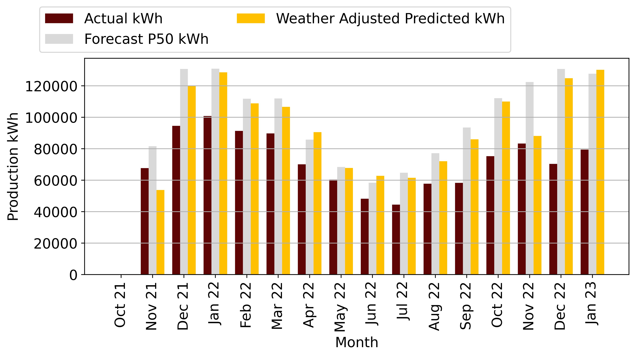

Figure 5‑1: Durbanville Production Vs Forecas

The table and figure above show the performance ratio in percentage for the month of January 2023, as well as the actual performance ratio compared to the forecasted performance ratio. The actual performance ratio for the month was 60%, which is lower than the forecasted performance ratio of 74%.

The delta percentage between the actual and forecasted performance ratio is -18.37%, which indicates that the actual energy production was lower than expected given the amount of sunlight received by the solar panels. This could be due to a variety of factors, such as equipment issues, shading, or modelling inaccuracies.

# Midstream Technical Performance

The following tables and figures on the technical performance and forecast data provide information on the production, irradiation, availability, and performance ratio of the plant compared to the forecast.

|  |  |
| --- | --- |
| **Project Overview** | |
| Design Capacity kW DC/AC (kW) | 227.9 / 200 |
| Achieved Capacity DC/AC (kW) | 227.9 / 220 |
| Technology | Solar |
| Project Company: | Moshesh Solar PV 1 (Pty) Ltd |
| Address: | Midstream Drive, Hill Boulevard Midstream Estate, Olifantsfontein. - South Africa |
| Commercial Operation Date | 27 October 2021 |

Table 6‑1: Midstream Project Overview

* 1. System Design

The plant is a 227.9kWp system with 535Wp JA Solar PV module connected to 2 Huawei 100 kW inverters. The system operates by using PV modules to generate DC electricity. DC is then converted to AC by the inverters for use in the buildings. The inverters installed by Mediclinic are grid tied with Anti-Islanding Protection.

* 1. Data Analysed

The following sections describes the performance of the system. We compiled data from the SCADA system and reviewed the monthly performance report from COD through to August 2022. No semi-annual Checklist Reports, Thermal Reports, Unscheduled Maintenance Reports, Harmattan has used only the SCADA to analyse the performance of the system. We note that the Operator has not provided the monthly schedule of maintenance activities undertaken, or list of available spare parts.

## Midstream Irradiation Vs Forecast

The following table and graph describe the irradiance of the site compared to the Helioscope P50 prediction. Harmattan notes that the irradiance measurement is satellite-based.

The site has been measuring irradiance since April to the present, and no irradiance data is available prior to that time.

|  |  |  |  |
| --- | --- | --- | --- |
| **Irradiation (kWh/m2)** | | | |
| **Month** | **Actual** | **Forecast** | **Delta (%)** |
| Oct 21 | 0 | 199 | -100.0 |
| Nov 21 | 196 | 200 | -1.73 |
| Dec 21 | 184 | 216 | -14.84 |
| Jan 22 | 182 | 208 | -12.4 |
| Feb 22 | 184 | 176 | 4.56 |
| Mar 22 | 157 | 177 | -11.29 |
| Apr 22 | 127 | 144 | -11.98 |
| May 22 | 131 | 134 | -2.24 |
| Jun 22 | 123 | 119 | 4.09 |
| Jul 22 | 127 | 131 | -3.25 |
| Aug 22 | 164 | 158 | 3.73 |
| Sep 22 | 183 | 179 | 2.15 |
| Oct 22 | 186 | 199 | -6.66 |
| Nov 22 | 170 | 200 | -14.69 |
| Dec 22 | 197 | 216 | -8.83 |
| Jan 23 | 231 | 205 | 12.39 |

Table 6‑3: Midstream Irradiation and Forecast

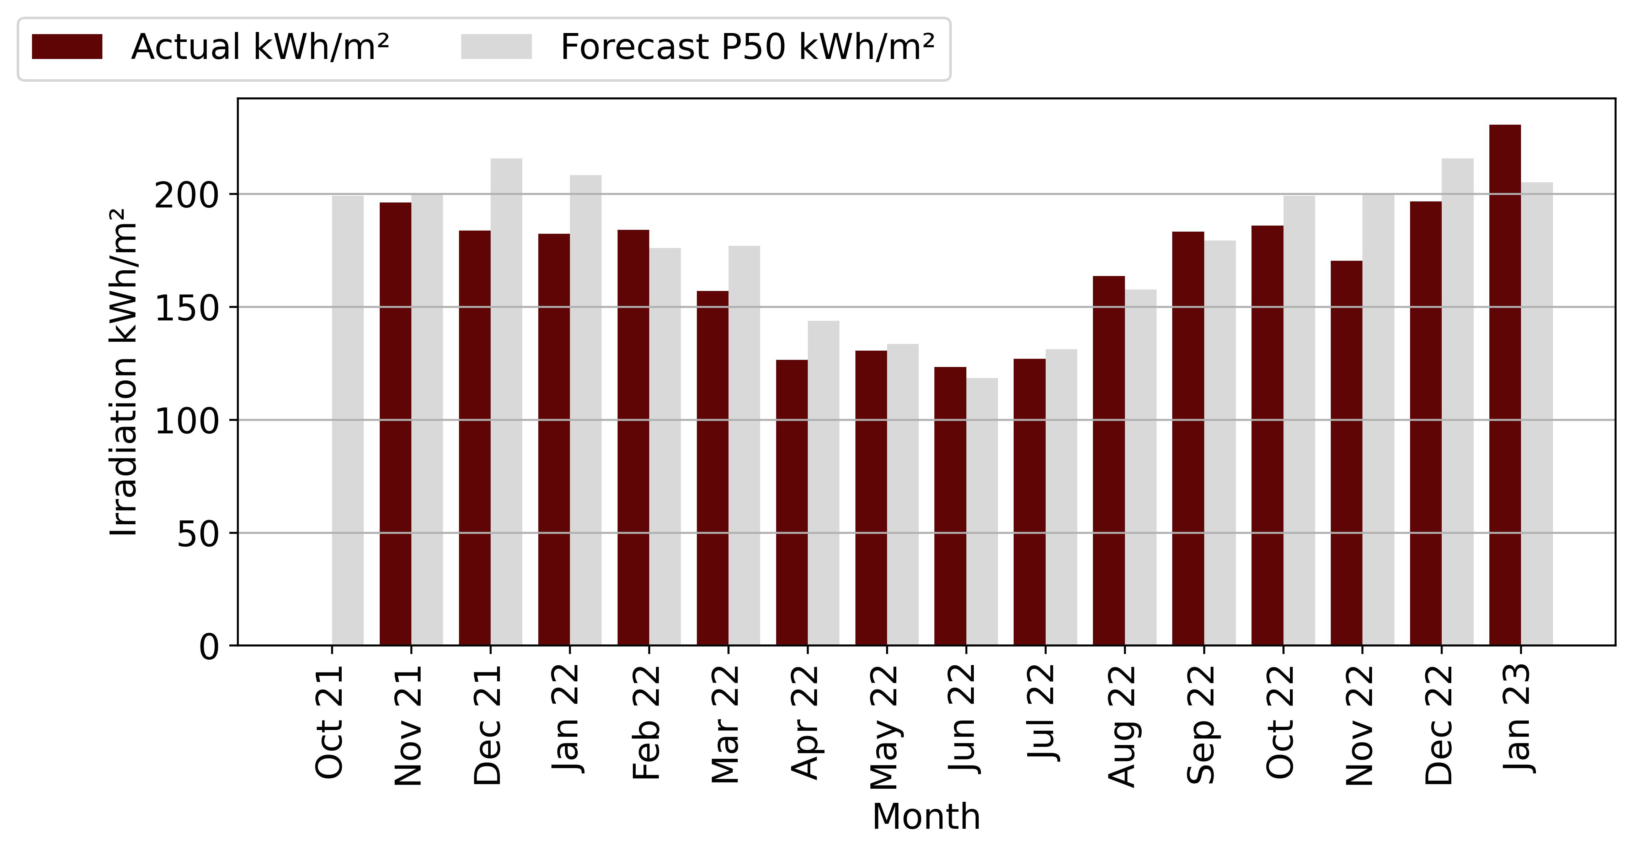

Figure 6‑2: Midstream Irradiation Vs Forecast

The above table and figure show that solar irradiance from April 2022 to August 2022 is below projections. In the absence of data from previous months, Harmattan cannot confirm whether the facility has experienced good or poor solar irradiance levels since COD. We can only state that the irradiance is poor compared to the P50 irradiance.

## Midstream Availability Vs Forecast

The following table and chart describe the availability of the plant since COD, comparing the availability of the plant with the guaranteed minimum availability of 95 %.

|  |  |  |  |
| --- | --- | --- | --- |
| **Availability (%)** | | | |
| **Month** | **Actual** | **Forecast** | **Delta (%)** |
| Oct 21 | 100 | 95 | 5.26 |
| Nov 21 | 100 | 95 | 5.26 |
| Dec 21 | 100 | 95 | 5.26 |
| Jan 22 | 0 | 95 | -100.0 |
| Feb 22 | 64 | 95 | -32.35 |
| Mar 22 | 100 | 95 | 5.26 |
| Apr 22 | 97 | 95 | 1.78 |
| May 22 | 96 | 95 | 0.99 |
| Jun 22 | 100 | 95 | 5.26 |
| Jul 22 | 94 | 95 | -1.29 |
| Aug 22 | 99 | 95 | 3.97 |
| Sep 22 | 84 | 95 | -11.66 |
| Oct 22 | 85 | 95 | -10.36 |
| Nov 22 | 82 | 95 | -13.45 |
| Dec 22 | 76 | 95 | -19.53 |
| Jan 23 | 83 | 95 | -12.62 |

Table 6‑4: Midstream Availability and Guaranteed

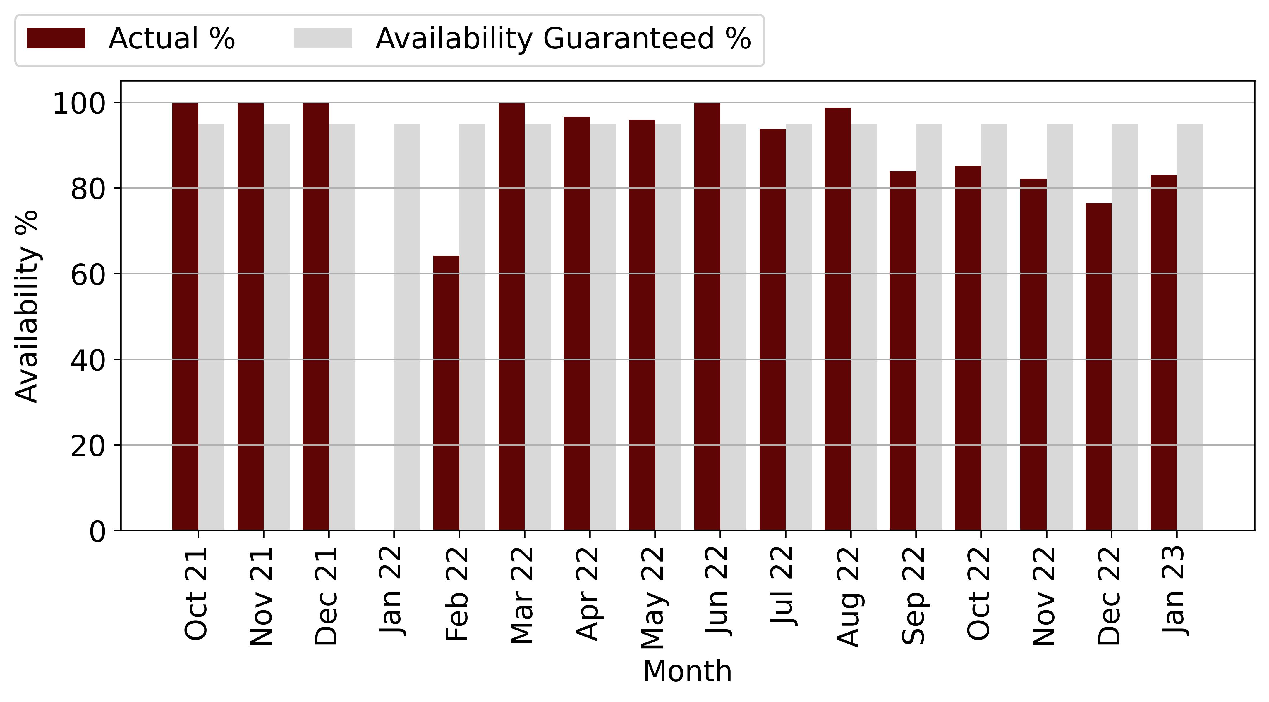

Figure 6‑3: Midstream Availability Vs Forecast

From the above table and graph, we can see that the plant has reached the minimum availability of 95 % for several months since COD.

We note that the plant did not reach the minimum availability in January 2022, February 2022 and July 2022 with a deviation of -1 to -32 % from the guaranteed availability. We also note that the plant has a high deviation in February 2022. Harmattan cannot confirm whether the high deviation is due to a fault in the SCADA system or caused by unplanned maintenance in February, as no maintenance report and checklist were provided.

The Operator has only stated that the availability of the power plant was mainly affected by load shedding. Harmattan recommends that the Operator submit the unscheduled maintenance reports for the site to confirm that the unavailability was due solely to load shedding.

## Midstream Performance Ratio Vs Forecast

The following table and chart compare the Scada Performance Ratio with the monthly forecast P50 PR of the Helioscope Forecast report.

|  |  |  |  |
| --- | --- | --- | --- |
| **Performance Ratio (%)** | | | |
| **Month** | **Actual** | **Forecast** | **Delta (%)** |
| Oct 21 | 0 | 0 | 0 |
| Nov 21 | 0 | 0 | 0 |
| Dec 21 | 0 | 0 | 0 |
| Jan 22 | 0 | 0 | 0 |
| Feb 22 | 0 | 0 | 0 |
| Mar 22 | 0 | 0 | 0 |
| Apr 22 | 81 | 75 | 8.97 |
| May 22 | 75 | 74 | 1.67 |
| Jun 22 | 78 | 55 | 42.24 |
| Jul 22 | 73 | 66 | 10.53 |
| Aug 22 | 77 | 55 | 41.52 |
| Sep 22 | 56 | 79 | -29.31 |
| Oct 22 | 57 | 78 | -27.16 |
| Nov 22 | 0 | 78 | -100.0 |
| Dec 22 | 0 | 77 | -100.0 |
| Jan 23 | 78 | 77 | 0.57 |

Table 6‑5: Midstream PR and Forecast

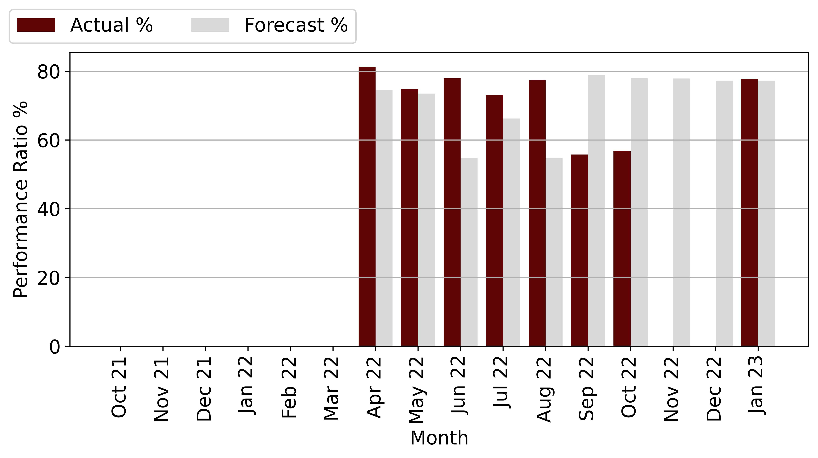

Figure 6‑4: Midstream PR Vs Forecast

rom the chart and table above, the performance ratio from May to date has fallen short of projections, ranging from -4.13 % to -10.86 %. Harmattan notes that the power plant's Performance Ratio has not improved, and due to a lack of data, cannot confirm whether it has lagged behind projections since COD.

The Operator has stated that the inadequate performance of the power plant is due to poor weather conditions that have resulted in lower irradiation than expected, as well as load shedding that results in production outages because the inverter cannot be put into operation for safety reasons.

## Midstream Production Vs Forecast

The following tables describe the production of the plant since COD. Production is compared to the P50 Helioscope forecast and the weather-adjusted forecast.

|  |  |  |  |  |  |
| --- | --- | --- | --- | --- | --- |
| **Month** | **Production (kWh)** | | | **Actual vs Original Forecast (%)** | **Actual vs Weather Adjusted Forecast (%)** |
| **Month** | **Original Forecast** | **Weather Adjusted Forecast** | **Actual Production** |
| Oct 21 | 4,608 | 0 | 4,350 | 0 | 0 |
| Nov 21 | 35,427 | 34,814 | 18,454 | -47.91 | -46.99 |
| Dec 21 | 37,840 | 32,223 | 48,331 | 27.72 | 49.99 |
| Jan 22 | 36,357 | 31,850 | 34,169 | -6.02 | 7.28 |
| Feb 22 | 31,491 | 32,927 | 32,937 | 4.59 | 0.03 |
| Mar 22 | 32,436 | 28,773 | 29,032 | -10.49 | 0.9 |
| Apr 22 | 27,152 | 23,899 | 23,636 | -12.95 | -1.1 |
| May 22 | 26,286 | 25,698 | 23,406 | -10.96 | -8.92 |
| Jun 22 | 23,828 | 24,802 | 21,763 | -8.66 | -12.25 |
| Jul 22 | 26,254 | 25,401 | 20,957 | -20.18 | -17.5 |
| Aug 22 | 30,459 | 31,597 | 29,575 | -2.9 | -6.4 |
| Sep 22 | 33,234 | 33,948 | 24,113 | -27.45 | -28.97 |
| Oct 22 | 35,710 | 33,331 | 29,329 | -17.87 | -12.01 |
| Nov 22 | 35,427 | 30,222 | 25,514 | -27.98 | -15.58 |
| Dec 22 | 37,840 | 34,498 | 26,685 | -29.48 | -22.65 |
| Jan 23 | 35,448 | 39,840 | 30,813 | -13.07 | -22.66 |
| **Total** | **489,798** | **463,824** | **423,065** | **-13.62** | **-8.79** |

Table 6‑2: Midstream Production and Forecast

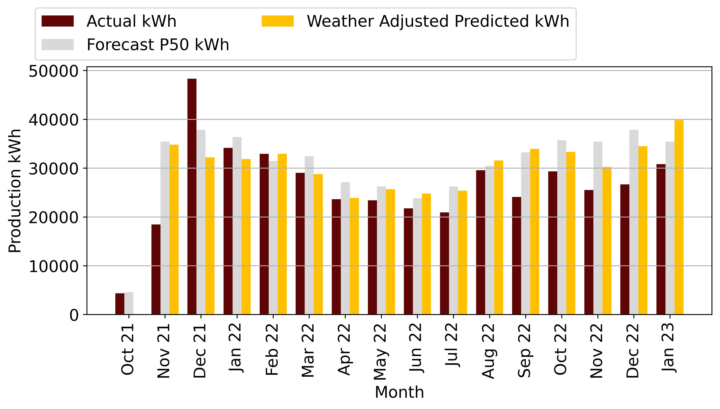

Figure 6‑1: Midstream Production Vs Forecast

Total production in February is 1kWh with a variance of 8.18% below the forecast production and 9.16% below the weather adjusted forecast.

Weather-adjusted generation is greater than the P50 forecast, meaning that the power plant could have met and exceeded P50 generation if the power plant had not curtailed during load shedding, which would have resulted in production losses. Another factor that could affect production losses is the soiling of the module in the middle of the river.

cleaning of the modules is needed for the site, especially in the dry season without rain.

# Hermanus Technical Performance

Technical performance tables and forecast figures below give details on plant Gross Generation, Irradiation, Availability and Performance Ratio compared against the Forecast/warranted values, then analyse the results and give recommendations.

|  |  |
| --- | --- |
| **Project Overview** | |
| Design Capacity (kW) DC/AC: | 211.7 / 200 |
| Achieved Capacity (kW) DC/AC | 211.7 / 220 |
| Technology | Solar |
| Project Company: | Moshesh Solar PV 1 (Pty) Ltd |
| Address: | Ravenscroft Rd Hermanus – 7,200 – South Africa |
| Commercial Operation Date | 10 March 2022 |

Table 7‑1: Hermanus Project Overview

## System Design

The system is a 211.7kWp system with 540Wp JA Solar PV modules connected to two Huawei 100 kW inverters. The system operates by using PV modules to generate DC electricity. DC electricity is then converted to AC electricity by the inverters for use in the buildings. The inverters installed by Mediclinic are grid tied with anti-islanding protection.

## Data Analysed

In the following sections, we describe the performance of the system. We compiled data from the SCADA system and reviewed the monthly performance report from COD to August 2022. The Operator submitted semi-annual Checklist Reports, Thermal Reports, and Unscheduled Maintenance Reports. Harmattan used these reports along with the SCADA system to analyse the performance of the system. We note that the Operator did not submit a monthly maintenance schedule or a list of available spare parts.

The performance data was downloaded from Higeco’s SCADA system and processed using Microsoft Excel. Harmattan reviewed the data and cleaned up the incomplete monthly data using Equation 2:

Based on SCADA data, irradiance, availability, performance ratio, and production were analysed. Irradiance data is based on the installed pyranometer, and availability and performance ratio are calculated using the SCADA system. Production is measured with a metre installed on site.

## Hermanus Irradiation Vs Forecast

The following table and graph describe the irradiance of the site compared to the Helioscope P50 prediction. Harmattan notes that the irradiance measurement is based on a pyranometer installed on site

The site has been measuring irradiance since April to the present, and no irradiance data is available prior to that time.

|  |  |  |  |
| --- | --- | --- | --- |
| **Irradiation (kWh/m2)** | | | |
| **Month** | **Actual** | **Forecast** | **Delta (%)** |
| Oct 21 | 0 | 186 | -100.0 |
| Nov 21 | 0 | 220 | -100.0 |
| Dec 21 | 0 | 243 | -100.0 |
| Jan 22 | 0 | 238 | -100.0 |
| Feb 22 | 0 | 190 | -100.0 |
| Mar 22 | 0 | 175 | -100.0 |
| Apr 22 | 126 | 123 | 2.09 |
| May 22 | 111 | 91 | 22.63 |
| Jun 22 | 90 | 74 | 21.95 |
| Jul 22 | 94 | 84 | 11.88 |
| Aug 22 | 121 | 106 | 14.31 |
| Sep 22 | 153 | 142 | 7.47 |
| Oct 22 | 175 | 186 | -5.54 |
| Nov 22 | 204 | 220 | -7.16 |
| Dec 22 | 210 | 243 | -13.78 |
| Jan 23 | 223 | 238 | -6.32 |

Table 7‑3: Hermanus irradiation and Forecast

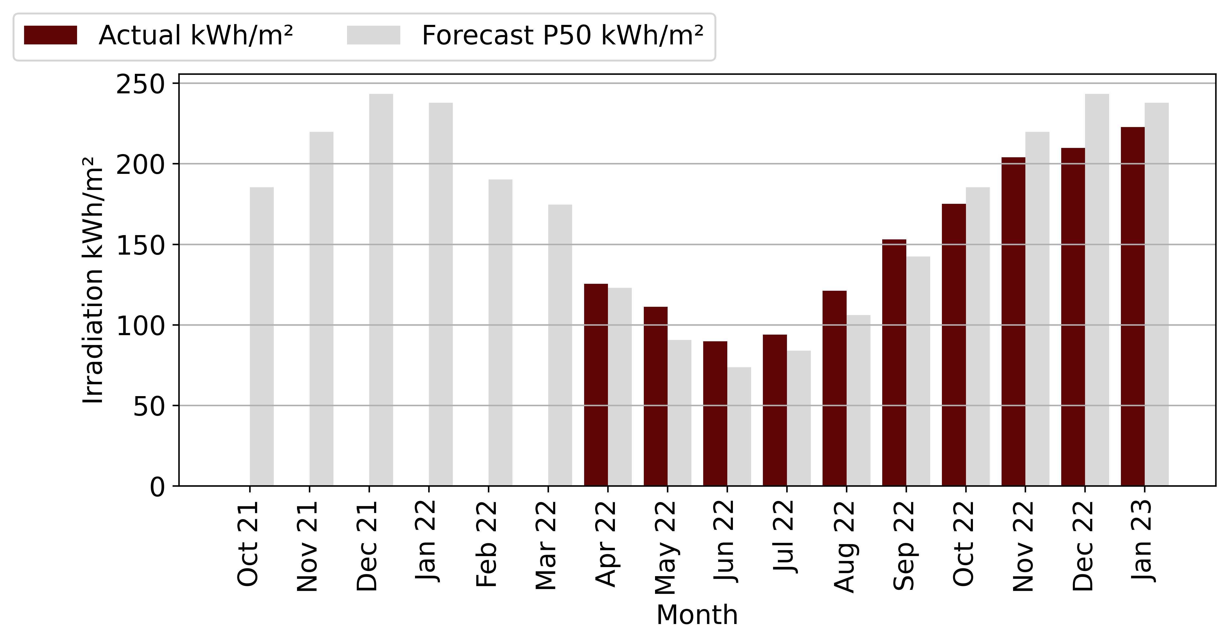

Figure 7‑3: Hermanus Irradiation Vs Forecast

The table and figure above show that the irradiation is below forecast in April 2022 to July 2022 and above in August 2022, May 2022 and June 2022.

## Hermanus Availability Vs Forecast

The following table and chart describe the availability of the plant since COD, comparing the availability of the plant with the guaranteed minimum availability of 95 %.

|  |  |  |  |
| --- | --- | --- | --- |
| **Availability (%)** | | | |
| Month | Actual | Forecast | Delta (%) |
| Oct 21 | 0 | 95 | -100.0 |
| Nov 21 | 0 | 95 | -100.0 |
| Dec 21 | 0 | 95 | -100.0 |
| Jan 22 | 0 | 95 | -100.0 |
| Feb 22 | 0 | 95 | -100.0 |
| Mar 22 | 100 | 95 | 5.26 |
| Apr 22 | 93 | 95 | -1.62 |
| May 22 | 96 | 95 | 0.97 |
| Jun 22 | 92 | 95 | -3.35 |
| Jul 22 | 88 | 95 | -7.32 |
| Aug 22 | 100 | 95 | 5.22 |
| Sep 22 | 80 | 95 | -15.63 |
| Oct 22 | 88 | 95 | -7.82 |
| Nov 22 | 90 | 95 | -5.79 |
| Dec 22 | 75 | 95 | -20.82 |
| Jan 23 | 73 | 95 | -23.17 |

Table 7‑4: Hermanus Availability and Forecast

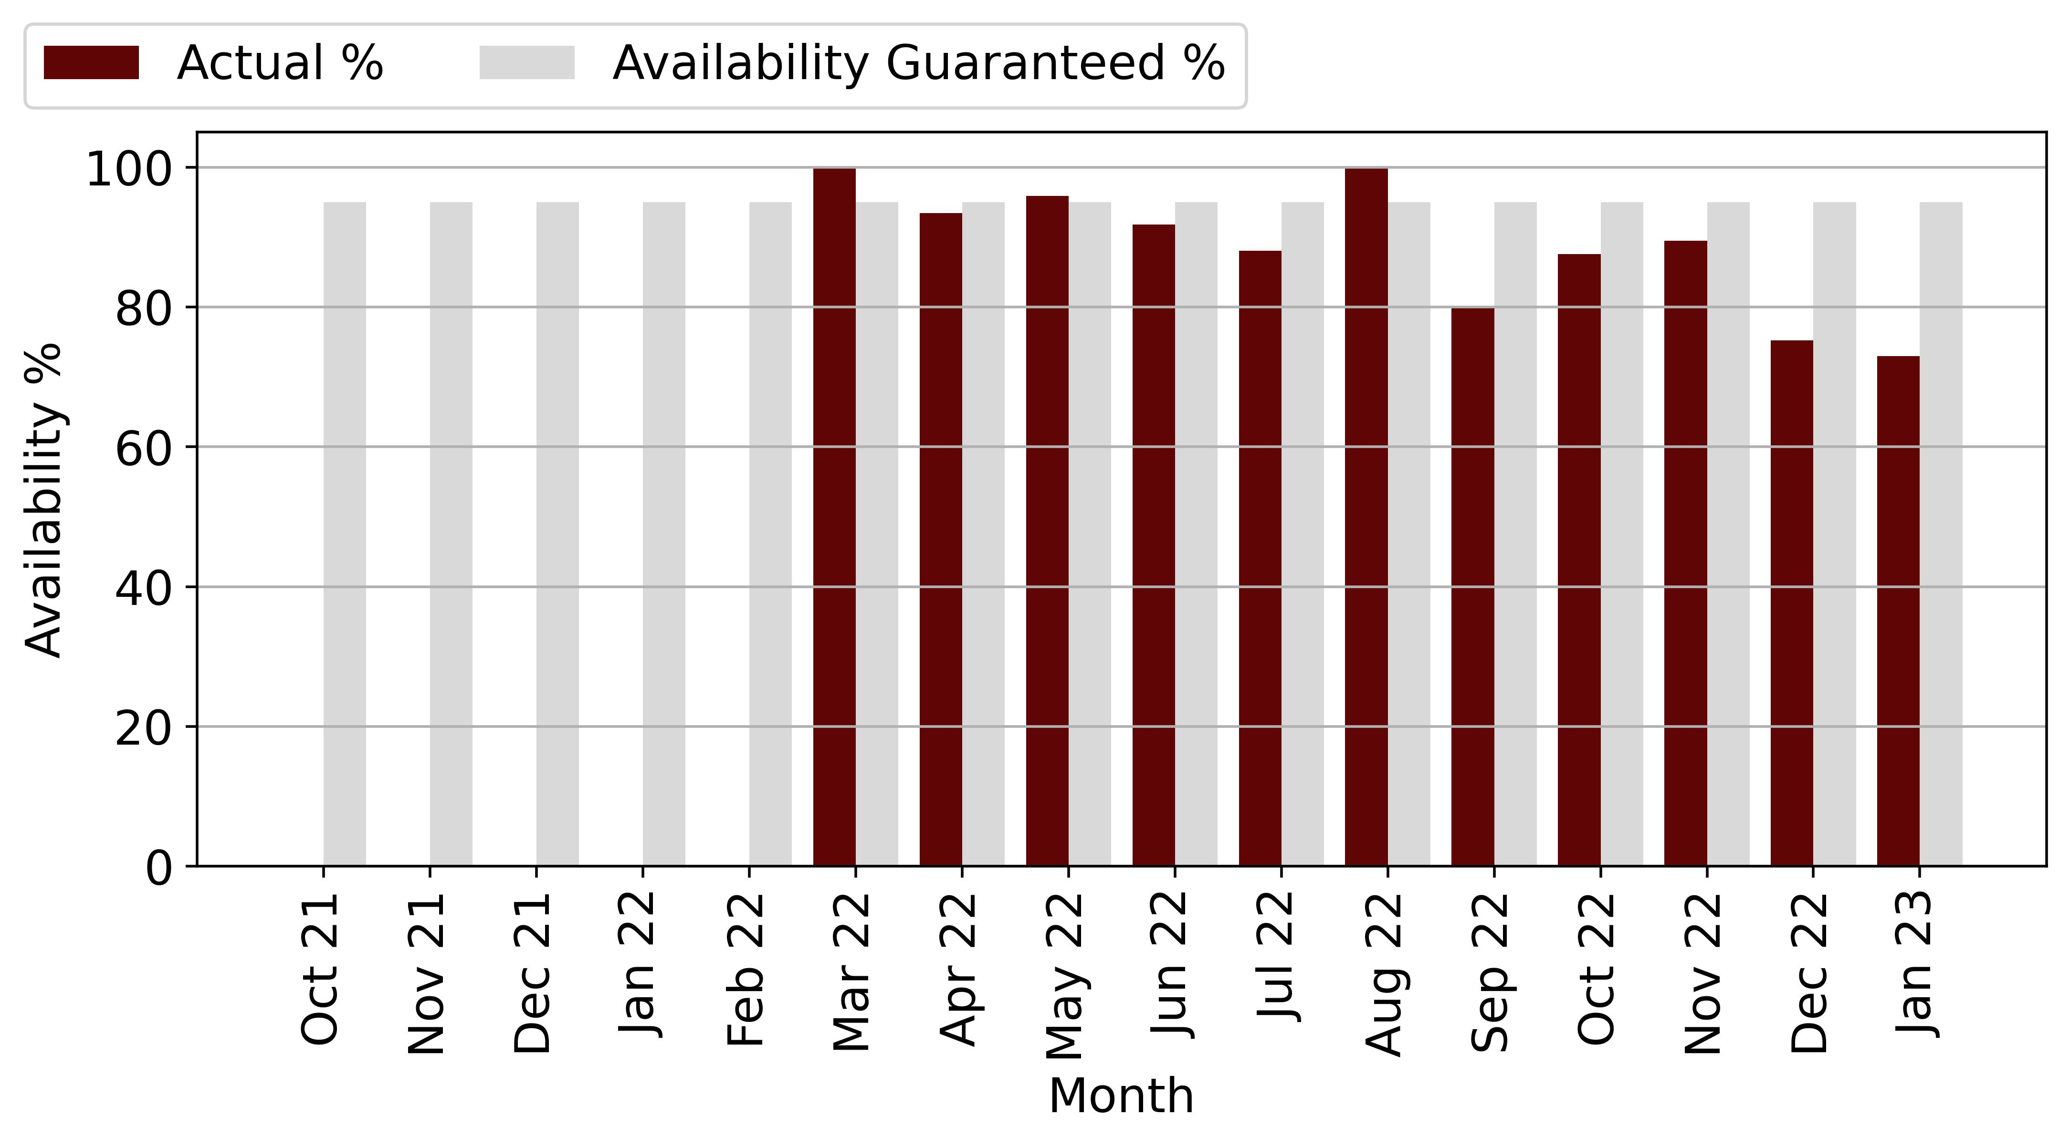

Figure 7‑4: Hermanus Availability Vs Forecast

From the above table and chart, it appears that the power plant has not met the minimum availability of 95 % since COD for some months. Harmattan cannot confirm if the unavailability of the power plant is due to unscheduled maintenance as no report has been submitted. The Operator has indicated that the availability of the power plant was mainly affected by load shedding. Harmattan recommends that the Operator submit the unscheduled maintenance reports for the site to confirm this.

## Hermanus Performance Ratio Vs Forecast

The following table and chart compare the Scada Performance Ratio with the monthly forecast P50 PR of the Helioscope Forecast report.

|  |  |  |  |
| --- | --- | --- | --- |
| **Performance Ratio (%)** | | | |
| **Month** | **Actual** | **Forecast** | **Delta (%)** |
| Oct 21 | 0 | 0 | 0 |
| Nov 21 | 0 | 0 | 0 |
| Dec 21 | 0 | 0 | 0 |
| Jan 22 | 0 | 0 | 0 |
| Feb 22 | 0 | 0 | 0 |
| Mar 22 | 0 | 0 | 0 |
| Apr 22 | 78 | 80 | -2.76 |
| May 22 | 82 | 87 | -5.8 |
| Jun 22 | 79 | 87 | -8.85 |
| Jul 22 | 76 | 87 | -12.35 |
| Aug 22 | 88 | 88 | 0.05 |
| Sep 22 | 70 | 87 | -20.14 |
| Oct 22 | 76 | 86 | -12.22 |
| Nov 22 | 79 | 86 | -8.05 |
| Dec 22 | 66 | 85 | -21.98 |
| Jan 23 | 64 | 83 | -22.1 |

Table 7‑5: Hermanus PR and Forecast

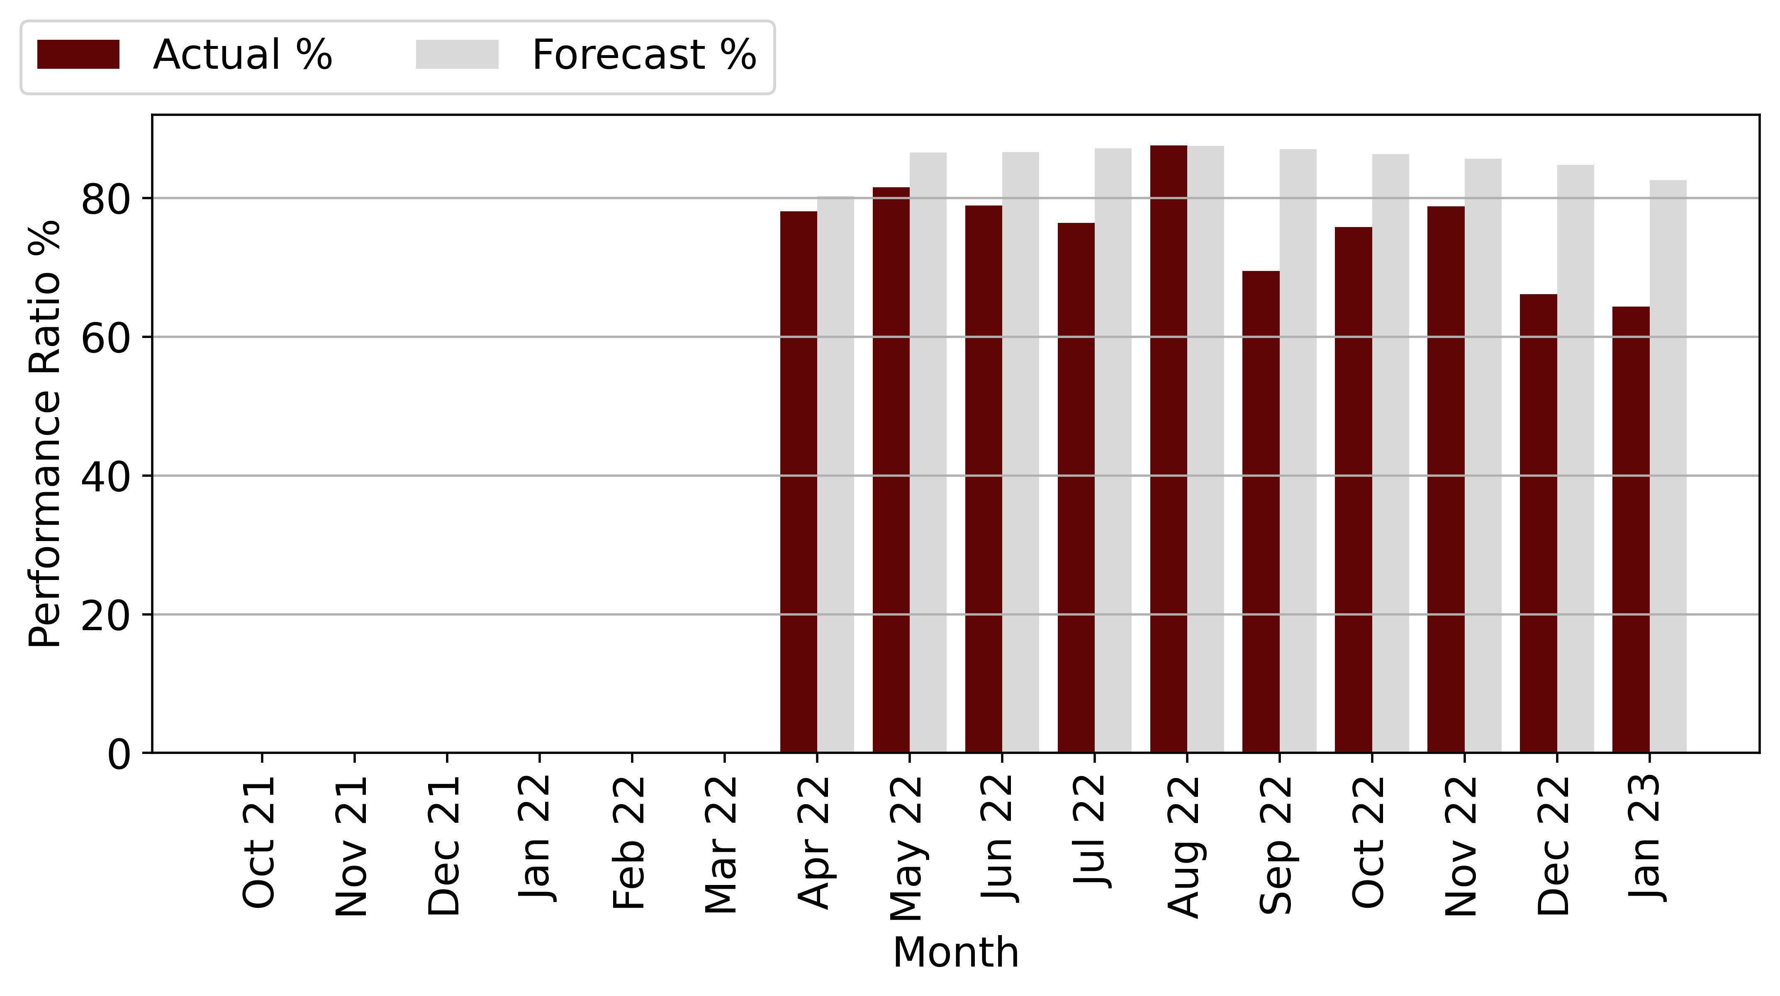

Figure 7‑5: Hermanus PR Vs Forecast

Harmattan notes that the power plant's performance from April 2022 to July 2022 was below the expected forecast, with a variance of -5.18 % to -12.35 %.

Harmattan notes that the power plant's performance ratio improved in August 2022. The Operator has stated that the inadequate performance of the power plant was due to poor weather conditions, which resulted in lower irradiation than expected, and load shedding, which resulted in production losses because the inverter could not be operated for safety reasons.

## Hermanus Production Vs Forecast

The following tables describe the production of the plant since March 2022 COD. Production is compared to the P50 Helioscope forecast and the weather-adjusted forecast.

289,835

|  |  |  |  |  |  |
| --- | --- | --- | --- | --- | --- |
| **Month** | **Production (kWh)** | | | **Actual vs Original Forecast (%)** | **Actual vs Weather Adjusted Forecast (%)** |
|  | **Original Forecast** | **Weather Adjusted Forecast** | **Actual Production** |
| Oct 21 | 0 | 0 | 0 | 0 | 0 |
| Nov 21 | 0 | 0 | 0 | 0 | 0 |
| Dec 21 | 0 | 0 | 0 | 0 | 0 |
| Jan 22 | 42,604 | 0 | 0 | 0 | 0 |
| Feb 22 | 35,031 | 0 | 0 | 0 | 0 |
| Mar 22 | 33,134 | 0 | 17,949 | 0 | 0 |
| Apr 22 | 24,643 | 25,158 | 21,947 | -10.94 | -12.76 |
| May 22 | 18,855 | 23,122 | 19,453 | 3.17 | -15.87 |
| Jun 22 | 15,569 | 18,986 | 15,026 | -3.49 | -20.86 |
| Jul 22 | 17,679 | 19,779 | 15,238 | -13.81 | -22.96 |
| Aug 22 | 21,796 | 24,916 | 22,528 | 3.36 | -9.58 |
| Sep 22 | 27,917 | 30,002 | 23,106 | -17.23 | -22.99 |
| Oct 22 | 35,026 | 33,085 | 28,544 | -18.5 | -13.72 |
| Nov 22 | 40,143 | 37,267 | 34,777 | -13.37 | -6.68 |
| Dec 22 | 43,621 | 37,610 | 29,747 | -31.8 | -20.91 |
| Jan 23 | 42,604 | 39,909 | 30,525 | -28.35 | -23.52 |
| **Total** | **398,618** | **289,835** | **258,841** | **-35.07** | **-10.69** |

Table 7‑2: Hermanus Production and Forecast

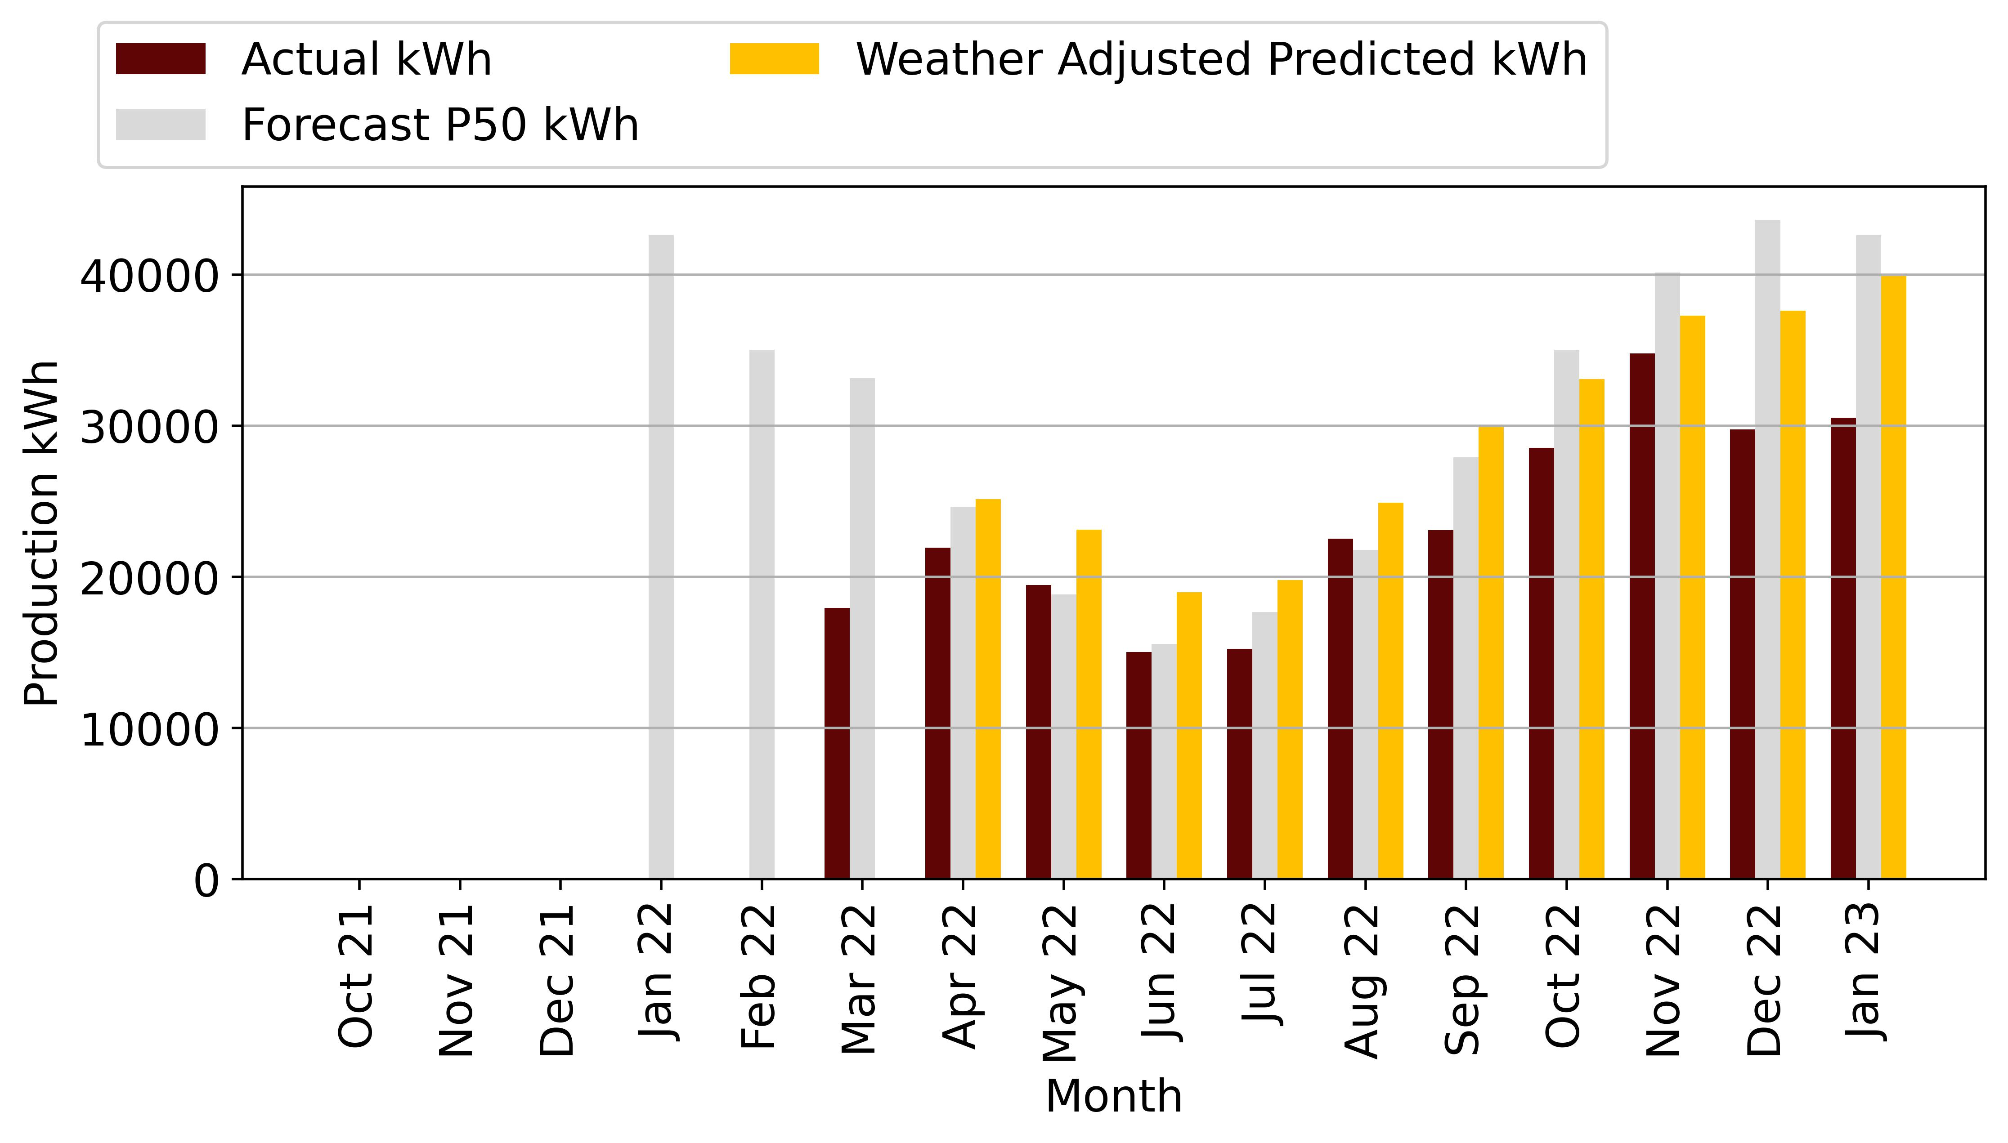

Figure 7‑1: Hermanus Production Vs Forecast

This shows that weather conditions had an impact on the power plant not meeting the P50 forecast, but we note that weather cannot be the only reason for the low production, as the weather-adjusted production is lower than original P50 forecast. The Operator has stated that the high deviation may be due to load shedding that resulted in production outages.

# Vergelegen Technical Performance

The following section summarises the Vergelegen project and highlights its technical performance. Key Performance indicators including production, irradiation, availability, and performance ratio were assessed from the SCADA , and compared to the forecast.

|  |  |
| --- | --- |
| **Project Overview** | |
| Design Capacity DC/AC (kW) | 697.1 / 650 |
| Achieved Capacity DC/AC (kW) | 689.6 / 650 |
| Technology | Solar |
| Project Company: | Moshesh Solar PV 1 (Pty) Ltd |
| Address: | Vergelegen, Main Road Somerset West South Africa |
| Commercial Operation Date | 28 Oct 2022 |

Table 8‑1: Vergelegen Project Overview

## System Design

The system is a 689.6kWp system with 535Wp JA Solar PV modules connected to six Huawei 100 kW inverters and one Huawei 50 kW inverter. The system works with PV modules that generate DC electricity. DC electricity is then converted to AC electricity so that it can be used in the buildings. Inverters are used to convert the electricity for this purpose. The inverters installed by Mediclinic are grid-connected and have anti-islanding protection.

## Data Analysed

In the following sections, we describe the performance of the system. We compiled data from the SCADA system and reviewed the monthly performance report from COD to August 2022. The Operator submitted semi-annual Checklist Reports, Thermal Reports, and Unscheduled Maintenance Reports. Harmattan used these reports along with the SCADA system to analyse the performance of the system. We note that the Operator did not submit a monthly maintenance schedule or a list of available spare parts.

The performance data was downloaded from Higeco’s SCADA system and processed using Microsoft Excel. Harmattan reviewed the data and cleaned up the incomplete monthly data using Equation 2:

Based on SCADA data, irradiance, availability, performance ratio, and production were analysed. Irradiance data is based on the installed pyranometer, and availability and performance ratio are calculated using the SCADA system. Production is measured with a meter installed on site.

## Vergelegen Irradiation Vs Forecast

The following table and graph describe the irradiance of the site compared to the Helioscope P50 prediction. Harmattan notes that the irradiance measurement is satellite-based. The site has been measuring irradiance since April to the present, and no irradiance data is available prior to that time.

|  |  |  |  |
| --- | --- | --- | --- |
| **Irradiation (kWh/m2)** | | | |
| **Month** | **Actual** | **Forecast** | **Delta (%)** |
| Oct 21 | 0 | 194 | -100.0 |
| Nov 21 | 207 | 229 | -9.66 |
| Dec 21 | 223 | 254 | -12.27 |
| Jan 22 | 247 | 252 | -2.04 |
| Feb 22 | 199 | 203 | -2.02 |
| Mar 22 | 173 | 186 | -7.3 |
| Apr 22 | 132 | 128 | 3.16 |
| May 22 | 92 | 91 | 0.75 |
| Jun 22 | 79 | 74 | 6.92 |
| Jul 22 | 75 | 83 | -9.4 |
| Aug 22 | 97 | 107 | -9.72 |
| Sep 22 | 133 | 146 | -8.55 |
| Oct 22 | 193 | 194 | -0.58 |
| Nov 22 | 371 | 229 | 62.06 |
| Dec 22 | 239 | 254 | -5.86 |
| Jan 23 | 247 | 252 | -1.77 |

Table 8‑3: Vergelegen irradiation and Forecast

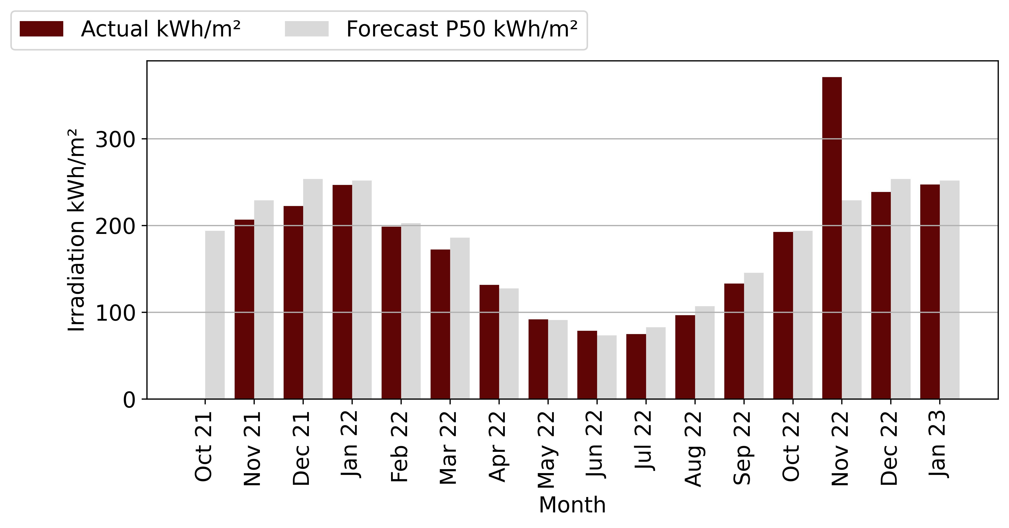

Figure 8‑3: Vergelegen Irradiation Vs Forecast

From the above table and figure, solar radiation was above forecast in May, June, and August, while it was below forecast in April and July. In the absence of data from previous months, Harmattan cannot confirm whether solar irradiation has been good or bad since COD.

## Vergelegen Availability Vs Forecast

The following table and chart describe the availability of the plant since COD, comparing the availability of the plant with the guaranteed minimum availability of 95 %.

|  |  |  |  |
| --- | --- | --- | --- |
| **Availability (%)** | | | |
| **Month** | **Actual** | **Forecast** | **Delta (%)** |
| Oct 21 | 16 | 9 | 72.19 |
| Nov 21 | 92 | 95 | -2.95 |
| Dec 21 | 100 | 95 | 5.26 |
| Jan 22 | 99 | 95 | 4.03 |
| Feb 22 | 99 | 95 | 4.52 |
| Mar 22 | 100 | 95 | 5.26 |
| Apr 22 | 97 | 95 | 1.93 |
| May 22 | 99 | 95 | 4.48 |
| Jun 22 | 92 | 95 | -3.14 |
| Jul 22 | 92 | 95 | -3.53 |
| Aug 22 | 99 | 95 | 4.65 |
| Sep 22 | 93 | 95 | -1.65 |
| Oct 22 | 99 | 95 | 3.74 |
| Nov 22 | 100 | 95 | 5.26 |
| Dec 22 | 86 | 95 | -9.0 |
| Jan 23 | 85 | 95 | -10.71 |

Table 8‑4: Vergelegen Availability and Guaranteed

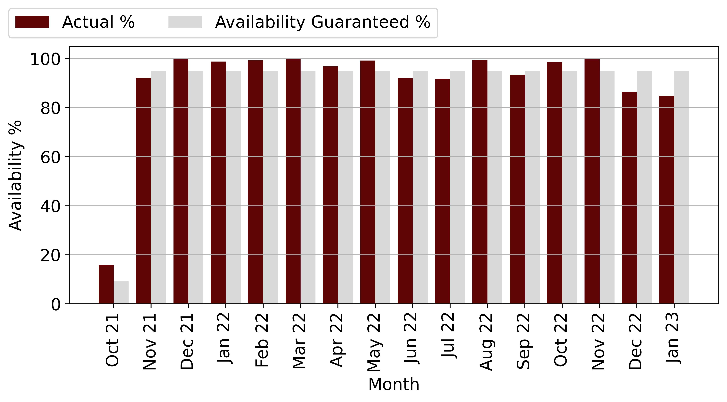

Figure 8‑4: Vergelegen Availability Vs Forecast

From the above table and graph, we can see that the plant has reached the minimum availability of 95 % for several months since COD. We note that the plant did not reach the minimum availability in November 2021, June 2022, July 2022 and August 2022 with a deviation of 3% to 4 % from the guaranteed availability.

We also note that the plant did not meet guaranteed availability in October 2021, but this is due to the fact that the plant was only in operation for four days, resulting in a misstatement of 15.83% availability. Harmattan cannot confirm whether the power plant's unavailability was due to unscheduled maintenance, as only one unscheduled event was reported.

The Operator has indicated that the availability of the power plant was mainly affected by load shedding. Harmattan recommends that the Operator submit the unscheduled maintenance reports for the site to confirm that the unavailability was due solely to load shedding

## Vergelegen Performance Ratio Vs Forecast

The following table and chart compare the Scada Performance Ratio with the monthly forecast P50 PR of the Helioscope Forecast report.

|  |  |  |  |
| --- | --- | --- | --- |
| **Performance Ratio (%)** | | | |
| **Month** | **Actual** | **Forecast** | **Delta (%)** |
| Oct 21 | 0 | 0 | 0 |
| Nov 21 | 0 | 0 | 0 |
| Dec 21 | 0 | 0 | 0 |
| Jan 22 | 0 | 0 | 0 |
| Feb 22 | 0 | 0 | 0 |
| Mar 22 | 0 | 0 | 0 |
| Apr 22 | 73 | 69 | 5.7 |
| May 22 | 78 | 81 | -4.21 |
| Jun 22 | 68 | 82 | -16.58 |
| Jul 22 | 72 | 80 | -9.87 |
| Aug 22 | 80 | 83 | -2.99 |
| Sep 22 | 73 | 82 | -9.98 |
| Oct 22 | 78 | 80 | -2.2 |
| Nov 22 | 0 | 78 | -100.0 |
| Dec 22 | 0 | 77 | -100.0 |
| Jan 23 | 94 | 75 | 25.78 |

Table 8‑5: Vergelegen PR and Forecast

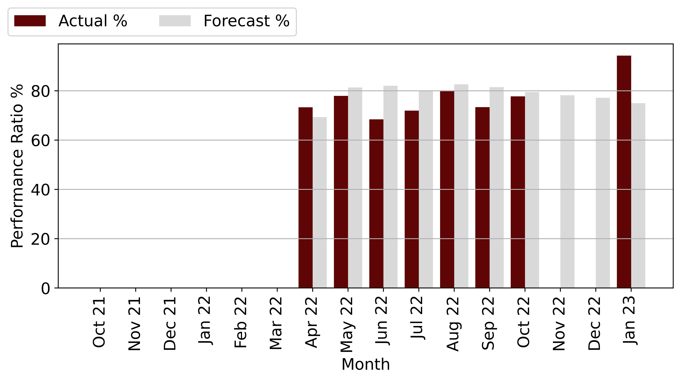

Figure 8‑5: Vergelegen PR Vs Forecast

From the chart and table above, it appears that the performance ratio from April to present has fallen short of projections, ranging from -2.99 % to -16.58 %. Harmattan notes that the power plant's Performance Ratio has not improved. Due to a lack of data, we cannot confirm whether it has lagged behind projections since COD.

The Operator has stated that the inadequate performance of the power plant is due to poor weather conditions that have resulted in lower irradiation than expected, as well as load shedding that results in production outages because the inverter cannot be put into operation for safety reasons.

## Vergelegen Production Vs Forecast

The following table describes the production of the project. Production was measured from COD to August 2022 and compared to the P50 forecast. Harmattan points out that October 2022 was not a full month, so production is low. Harmattan adjusted the forecast for the 3 days of operation. The resulting variance shows that the plant was above forecasts.

1,385,839

|  |  |  |  |  |  |
| --- | --- | --- | --- | --- | --- |
| **Month** | **Production (kWh)** | | | **Actual vs Original Forecast (%)** | **Actual vs Weather Adjusted Forecast (%)** |
|  | **Original Forecast** | **Weather Adjusted Forecast** | **Actual Production** |
| Oct 21 | 10,346 | 0 | 15,876 | 0 | 0 |
| Nov 21 | 124,191 | 112,190 | 114,667 | -7.67 | 2.21 |
| Dec 21 | 135,649 | 119,011 | 126,250 | -6.93 | 6.08 |
| Jan 22 | 134,331 | 131,591 | 127,625 | -4.99 | -3.01 |
| Feb 22 | 108,571 | 106,376 | 96,946 | -10.71 | -8.86 |
| Mar 22 | 100,729 | 93,379 | 94,648 | -6.04 | 1.36 |
| Apr 22 | 70,911 | 73,153 | 70,139 | -1.09 | -4.12 |
| May 22 | 51,576 | 51,961 | 52,488 | 1.77 | 1.01 |
| Jun 22 | 41,982 | 44,888 | 39,238 | -6.54 | -12.59 |
| Jul 22 | 47,500 | 43,033 | 42,440 | -10.65 | -1.38 |
| Aug 22 | 61,453 | 55,479 | 60,653 | -1.3 | 9.33 |
| Sep 22 | 82,460 | 75,411 | 73,643 | -10.69 | -2.34 |
| Oct 22 | 106,909 | 106,293 | 107,658 | 0.7 | 1.28 |
| Nov 22 | 124,191 | 201,269 | 100,687 | -18.93 | -49.97 |
| Dec 22 | 135,649 | 127,694 | 59,646 | -56.03 | -53.29 |
| Jan 23 | 130,973 | 128,654 | 203,236 | 55.17 | 57.97 |
| **Total** | **1,467,421** | **1,470,383** | **1,385,839** | **-5.56** | **-5.75** |

Table 8‑2: Vergelegen Production and Forecast

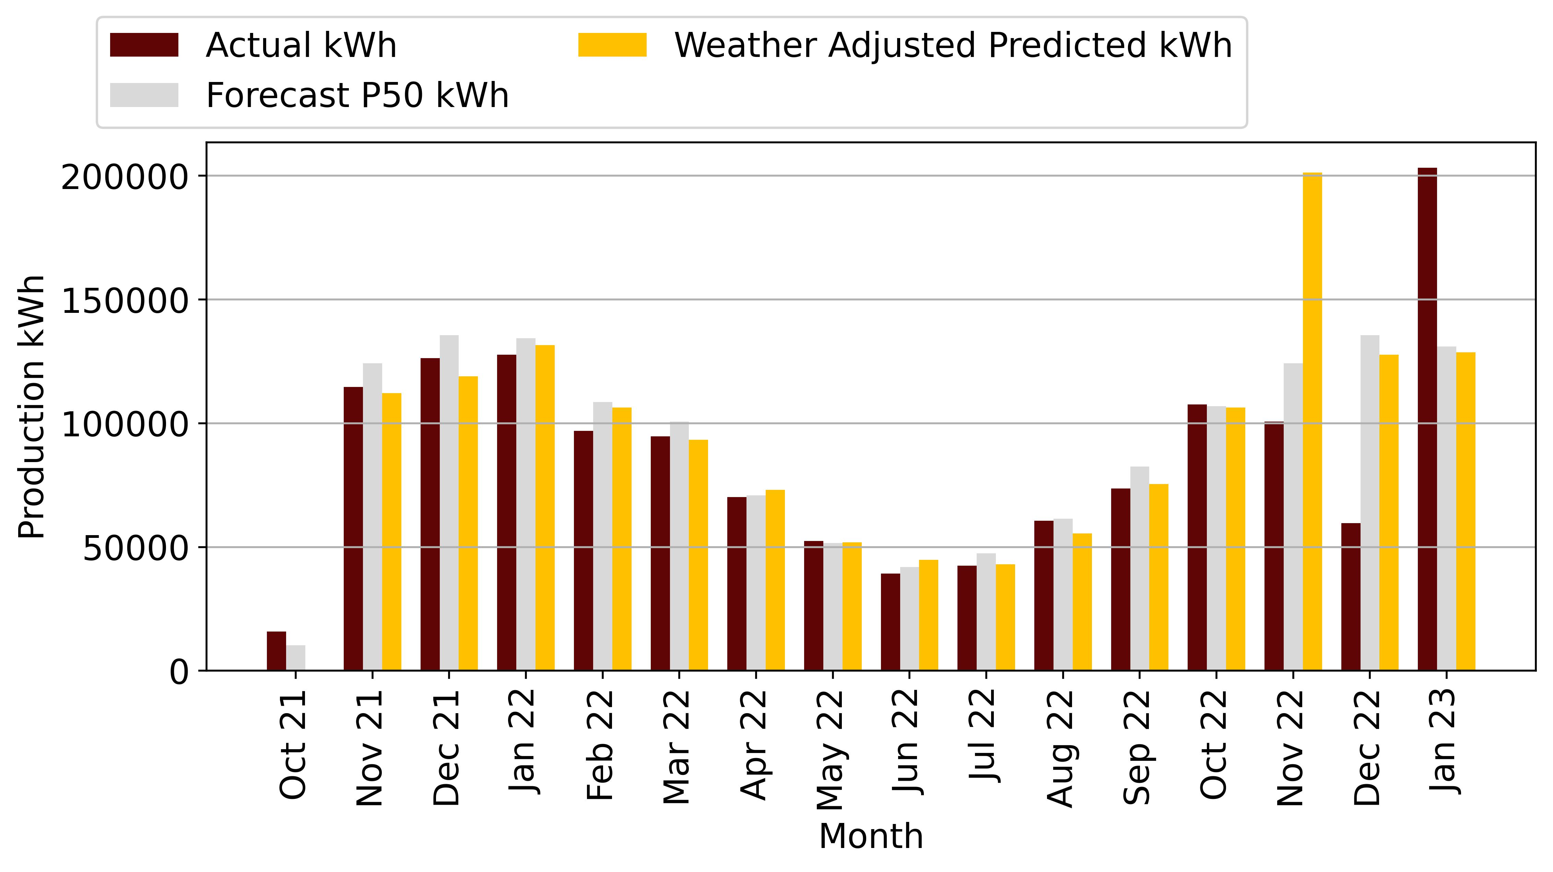

Figure 8‑1: Vergelegen Production Vs Forecast

Total production since COD is 840,969 kWh with a variance of 5.22 % below the original forecast and 4.99 % below the weather adjusted forecast.

The weather-adjusted generation is less than the P50 forecast, which means that the power plant could not exceed the P50 generation.

As the irradiation is low due to cloudy weather conditions since COD. The impact of load shedding is minimal. We have also considered the impact of inverters operating above guaranteed temperature range, as described below.

The following figure describes the inverter temperature at Vergelegen. The thermal image was taken on 30 March 2022, and shows that the inverter is operating at 50 ˚C, which is close to the maximum operating temperature of 60 ˚C. The high operating temperature of the inverter has implications for production. Harmattan notes that the inverter has not exceeded the maximum temperature of 60 ˚C but points out that this could change during the summer months.

Figure 8‑2: Vergelegen Production Vs Forecast

Harmattan notes that the Operator (Aces) has proposed that Mediclinic provide additional ventilation to the room where the inverters are located. This has not been done because the winter season has allowed for additional cooling of the inverter.

Harmattan recommends that the Operator provide Mediclinic with a specification for the required cooling of the equipment and conduct further thermal testing at the other sites. Harmattan will review the specification and costing provided by ACES.

# Tzaneen Technical Performance

The following section summarises the Tzaneen project and highlights its technical performance. Key Performance indicators including production, irradiation, availability, and performance ratio were assessed from the SCADA, and compared to the forecast.

|  |  |
| --- | --- |
| **Project Overview** | |
| Design Capacity DC/AC (kW) | 697.1 / 650 |
| Achieved Capacity DC/AC (kW) | 689.6 / 650 |
| Technology | Solar |
| Project Company: | Moshesh Solar PV 1 (Pty) Ltd |
| Address: | Tzaneen, Main Road Somerset West South Africa |
| Commercial Operation Date | 28 Oct 2022 |

Table 8‑1: Tzaneen Project Overview

## System Design

The system is a 689.6kWp system with 535Wp JA Solar PV modules connected to six Huawei 100 kW inverters and one Huawei 50 kW inverter. The system works with PV modules that generate DC electricity. DC electricity is then converted to AC electricity so that it can be used in the buildings. Inverters are used to convert the electricity for this purpose. The inverters installed by Mediclinic are grid-connected and have anti-islanding protection.

## Data Analysed

In the following sections, we describe the performance of the system. We compiled data from the SCADA system and reviewed the monthly performance report from COD to August 2022. The Operator submitted semi-annual Checklist Reports, Thermal Reports, and Unscheduled Maintenance Reports. Harmattan used these reports along with the SCADA system to analyse the performance of the system. We note that the Operator did not submit a monthly maintenance schedule or a list of available spare parts.

The performance data was downloaded from Higeco’s SCADA system and processed using Microsoft Excel. Harmattan reviewed the data and cleaned up the incomplete monthly data using Equation 2:

Based on SCADA data, irradiance, availability, performance ratio, and production were analysed. Irradiance data is based on the installed pyranometer, and availability and performance ratio are calculated using the SCADA system. Production is measured with a meter installed on site.

## Tzaneen Irradiation Vs Forecast

The following table and graph describe the irradiance of the site compared to the Helioscope P50 prediction. Harmattan notes that the irradiance measurement is satellite-based. The site has been measuring irradiance since April to the present, and no irradiance data is available prior to that time.

|  |  |  |  |
| --- | --- | --- | --- |
| **Irradiation (kWh/m2)** | | | |
| **Month** | **Actual** | **Forecast** | **Delta (%)** |
| Oct 21 | 0 | 0 | 0 |
| Nov 21 | 0 | 0 | 0 |
| Dec 21 | 0 | 0 | 0 |
| Jan 22 | 0 | 0 | 0 |
| Feb 22 | 0 | 0 | 0 |
| Mar 22 | 0 | 0 | 0 |
| Apr 22 | 0 | 0 | 0 |
| May 22 | 0 | 0 | 0 |
| Jun 22 | 0 | 0 | 0 |
| Jul 22 | 0 | 0 | 0 |
| Aug 22 | 0 | 0 | 0 |
| Sep 22 | 0 | 0 | 0 |
| Oct 22 | 0 | 154 | -100.0 |
| Nov 22 | 0 | 154 | -100.0 |
| Dec 22 | 168 | 168 | 0.16 |
| Jan 23 | 197 | 174 | 13.57 |

Table 8‑3: Tzaneen irradiation and Forecast

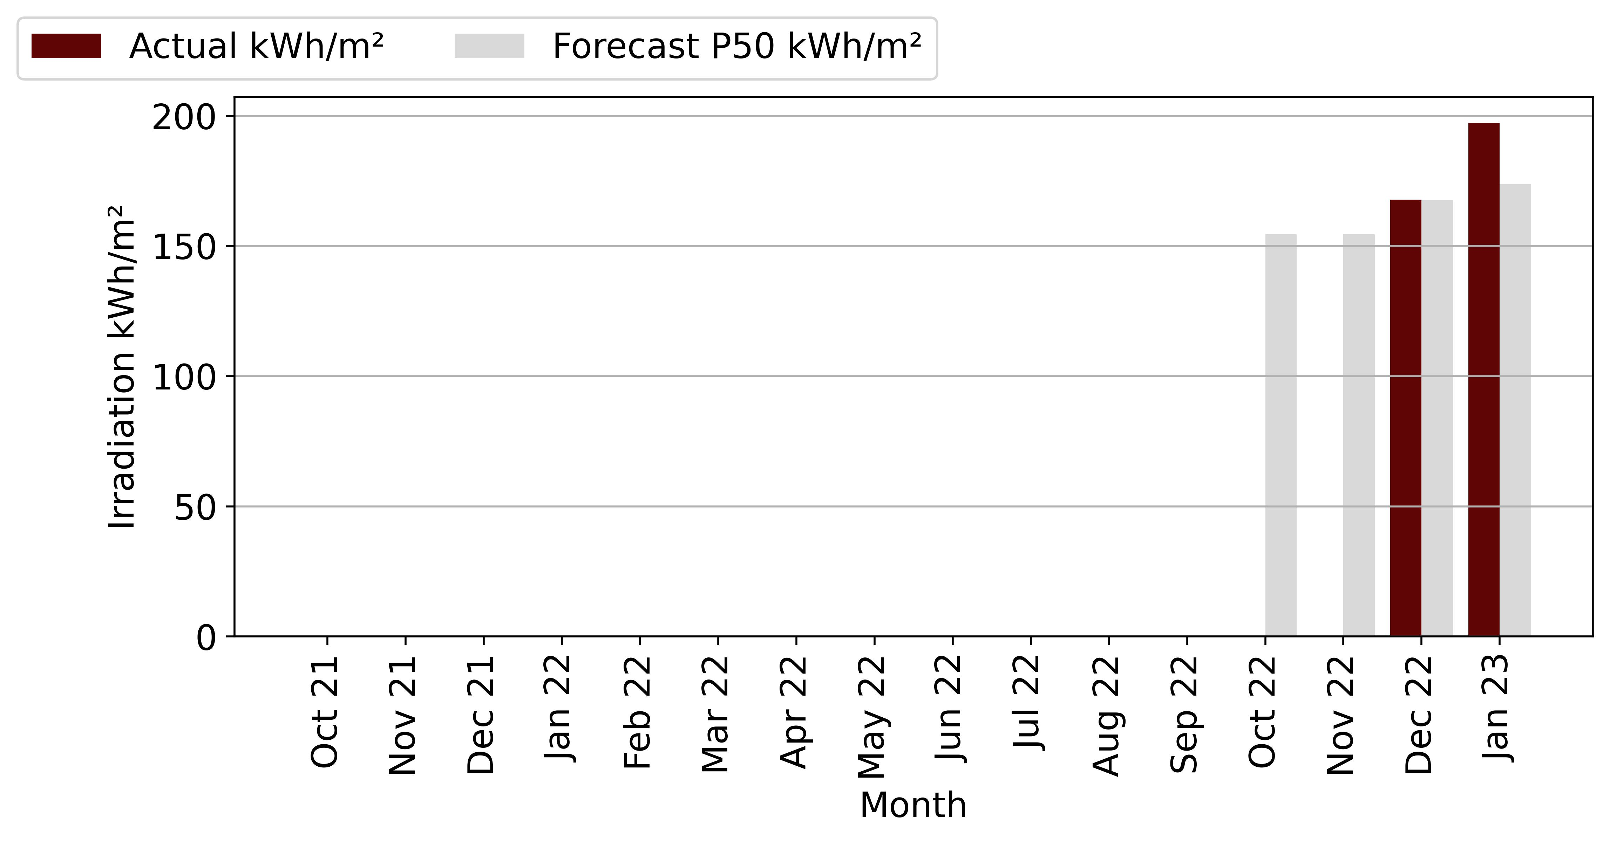

Figure 8‑3: Tzaneen Irradiation Vs Forecast

From the above table and figure, solar radiation was above forecast in May, June, and August, while it was below forecast in April and July. In the absence of data from previous months, Harmattan cannot confirm whether solar irradiation has been good or bad since COD.

## Tzaneen Availability Vs Forecast

The following table and chart describe the availability of the plant since COD, comparing the availability of the plant with the guaranteed minimum availability of 95 %.

|  |  |  |  |
| --- | --- | --- | --- |
| **Availability (%)** | | | |
| **Month** | **Actual** | **Forecast** | **Delta (%)** |
| Oct 21 | 0 | 95 | -100.0 |
| Nov 21 | 0 | 95 | -100.0 |
| Dec 21 | 0 | 95 | -100.0 |
| Jan 22 | 0 | 95 | -100.0 |
| Feb 22 | 0 | 95 | -100.0 |
| Mar 22 | 0 | 95 | -100.0 |
| Apr 22 | 0 | 95 | -100.0 |
| May 22 | 0 | 95 | -100.0 |
| Jun 22 | 0 | 95 | -100.0 |
| Jul 22 | 0 | 95 | -100.0 |
| Aug 22 | 0 | 95 | -100.0 |
| Sep 22 | 0 | 95 | -100.0 |
| Oct 22 | 0 | 95 | -100.0 |
| Nov 22 | 0 | 95 | -100.0 |
| Dec 22 | 0 | 95 | -100.0 |
| Jan 23 | 0 | 95 | -100.0 |

Table 8‑4: Tzaneen Availability and Guaranteed

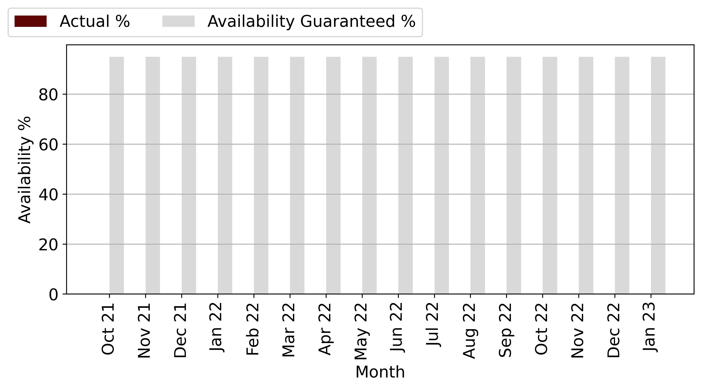

Figure 8‑4: Tzaneen Availability Vs Forecast

From the above table and graph, we can see that the plant has reached the minimum availability of 95 % for several months since COD. We note that the plant did not reach the minimum availability in November 2021, June 2022, July 2022 and August 2022 with a deviation of 3% to 4 % from the guaranteed availability.

We also note that the plant did not meet guaranteed availability in October 2021, but this is due to the fact that the plant was only in operation for four days, resulting in a misstatement of 15.83% availability. Harmattan cannot confirm whether the power plant's unavailability was due to unscheduled maintenance, as only one unscheduled event was reported.

The Operator has indicated that the availability of the power plant was mainly affected by load shedding. Harmattan recommends that the Operator submit the unscheduled maintenance reports for the site to confirm that the unavailability was due solely to load shedding.

## Tzaneen Performance Ratio Vs Forecast

The following table and chart compare the Scada Performance Ratio with the monthly forecast P50 PR of the Helioscope Forecast report.

|  |  |  |  |
| --- | --- | --- | --- |
| **Performance Ratio (%)** | | | |
| **Month** | **Actual** | **Forecast** | **Delta (%)** |
| Oct 21 | 0 | 0 | 0 |
| Nov 21 | 0 | 0 | 0 |
| Dec 21 | 0 | 0 | 0 |
| Jan 22 | 0 | 0 | 0 |
| Feb 22 | 0 | 0 | 0 |
| Mar 22 | 0 | 0 | 0 |
| Apr 22 | 0 | 0 | 0 |
| May 22 | 0 | 0 | 0 |
| Jun 22 | 0 | 0 | 0 |
| Jul 22 | 0 | 0 | 0 |
| Aug 22 | 0 | 0 | 0 |
| Sep 22 | 0 | 0 | 0 |
| Oct 22 | 0 | 83 | -100.0 |
| Nov 22 | 0 | 83 | -100.0 |
| Dec 22 | 0 | 83 | -100.0 |
| Jan 23 | 70 | 83 | -15.86 |

Table 8‑5: Tzaneen PR and Forecast

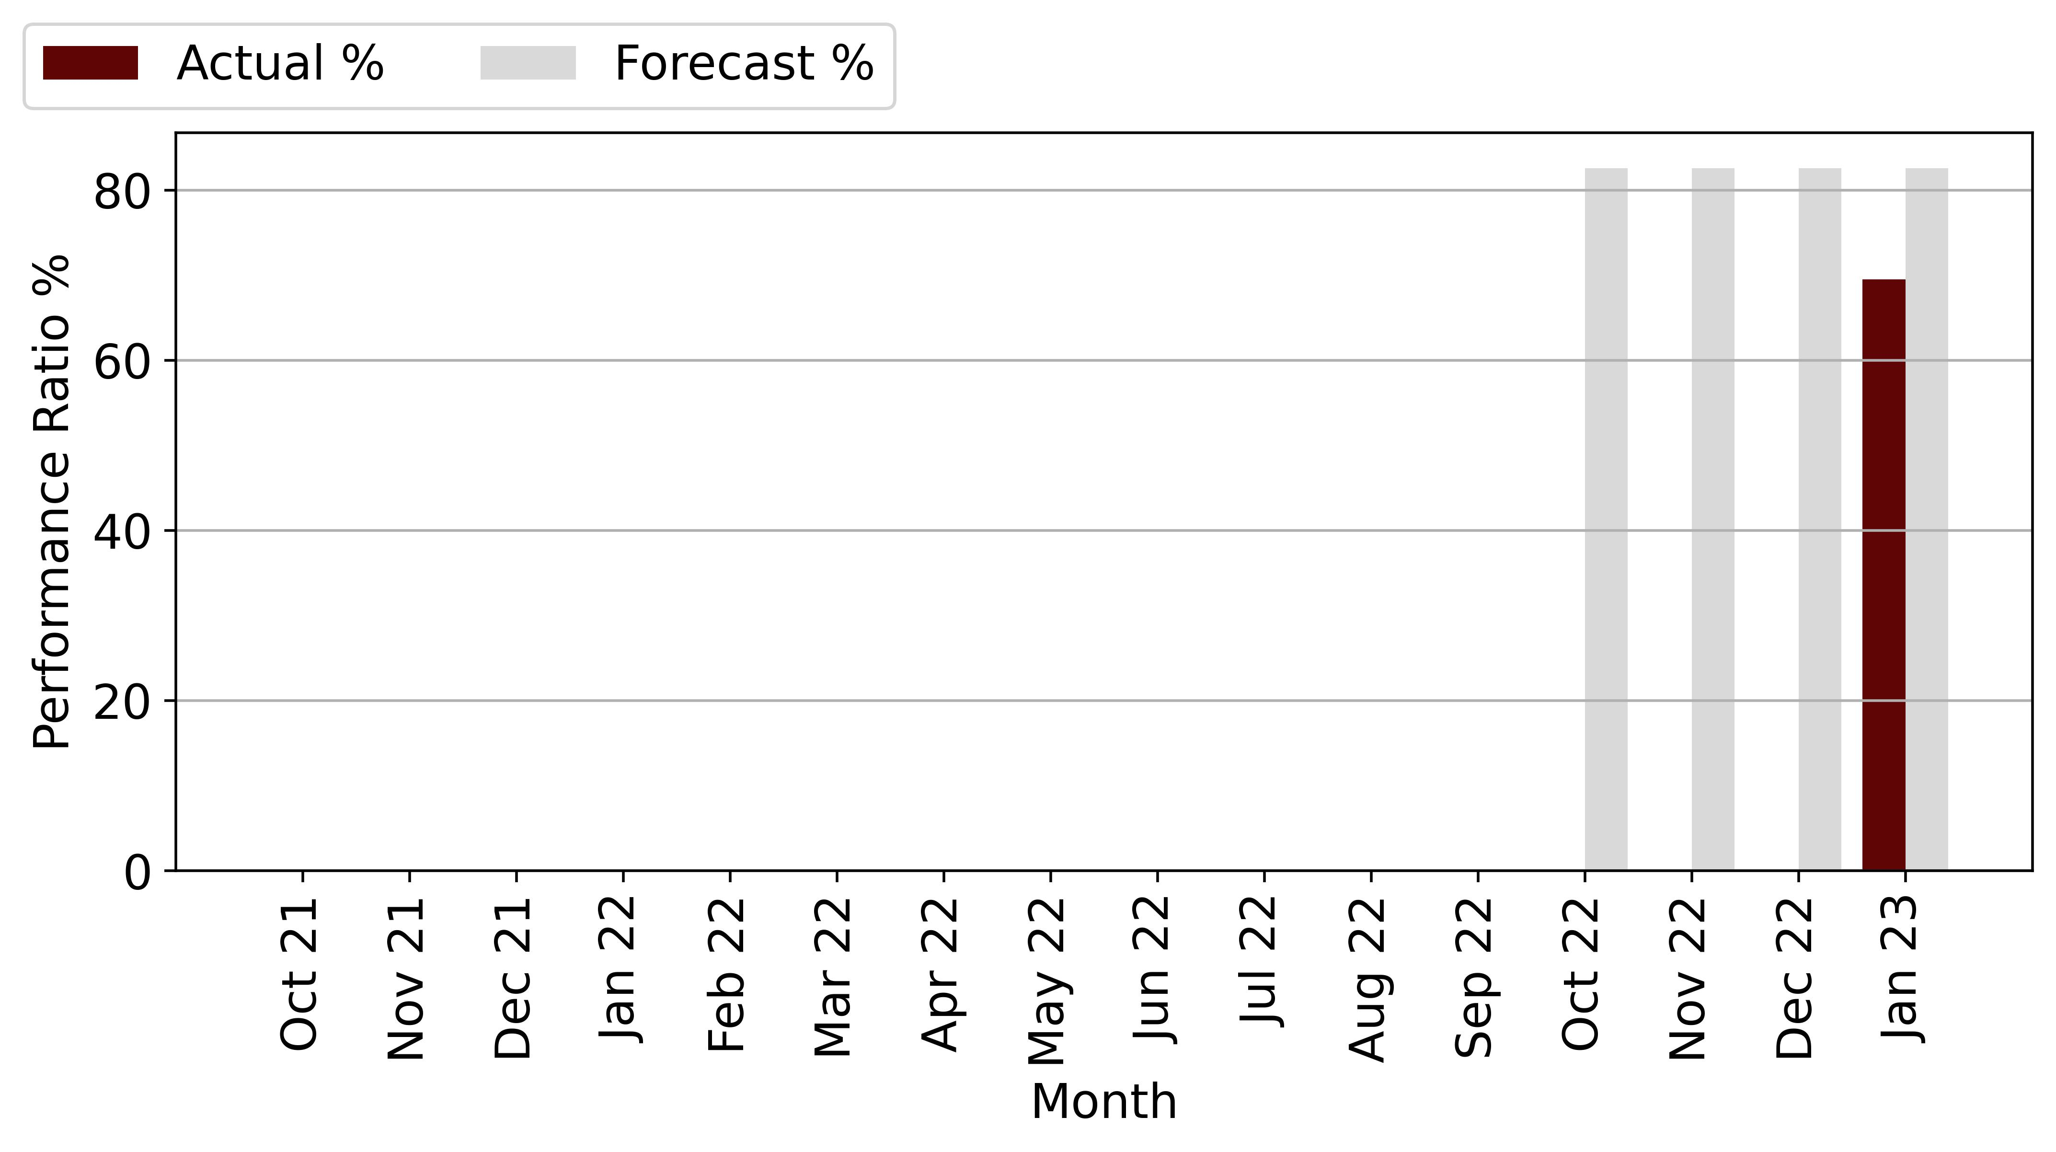

Figure 8‑5: Tzaneen PR Vs Forecast

From the chart and table above, it appears that the performance ratio from April to present has fallen short of projections, ranging from -2.99 % to -16.58 %. Harmattan notes that the power plant's Performance Ratio has not improved. Due to a lack of data, we cannot confirm whether it has lagged behind projections since COD.

The Operator has stated that the inadequate performance of the power plant is due to poor weather conditions that have resulted in lower irradiation than expected, as well as load shedding that results in production outages because the inverter cannot be put into operation for safety reasons.

## Tzaneen Production Vs Forecast

The following table describes the production of the project. Production was measured from COD to August 2022 and compared to the P50 forecast. Harmattan points out that October 2022 was not a full month, so production is low. Harmattan adjusted the forecast for the 3 days of operation. The resulting variance shows that the plant was above forecasts.

109,731

|  |  |  |  |  |  |
| --- | --- | --- | --- | --- | --- |
| **Month** | **Production (kWh)** | | | **Actual vs Original Forecast (%)** | **Actual vs Weather Adjusted Forecast (%)** |
|  | **Original Forecast** | **Weather Adjusted Forecast** | **Actual Production** |
| Oct 21 | 0 | 0 | 0 | 0 | 0 |
| Nov 21 | 0 | 0 | 0 | 0 | 0 |
| Dec 21 | 0 | 0 | 0 | 0 | 0 |
| Jan 22 | 0 | 0 | 0 | 0 | 0 |
| Feb 22 | 0 | 0 | 0 | 0 | 0 |
| Mar 22 | 0 | 0 | 0 | 0 | 0 |
| Apr 22 | 0 | 0 | 0 | 0 | 0 |
| May 22 | 0 | 0 | 0 | 0 | 0 |
| Jun 22 | 0 | 0 | 0 | 0 | 0 |
| Jul 22 | 0 | 0 | 0 | 0 | 0 |
| Aug 22 | 0 | 0 | 0 | 0 | 0 |
| Sep 22 | 0 | 0 | 0 | 0 | 0 |
| Oct 22 | 51,810 | 0 | 25,936 | 0 | 0 |
| Nov 22 | 51,176 | 0 | 3,936 | 0 | 0 |
| Dec 22 | 54,893 | 54,982 | 35,678 | -35.0 | -35.11 |
| Jan 23 | 56,838 | 64,553 | 44,182 | -22.27 | -31.56 |
| **Total** | **214,716** | **119,535** | **109,731** | **-48.89** | **-8.2** |

Table 8‑2: Tzaneen Production and Forecast

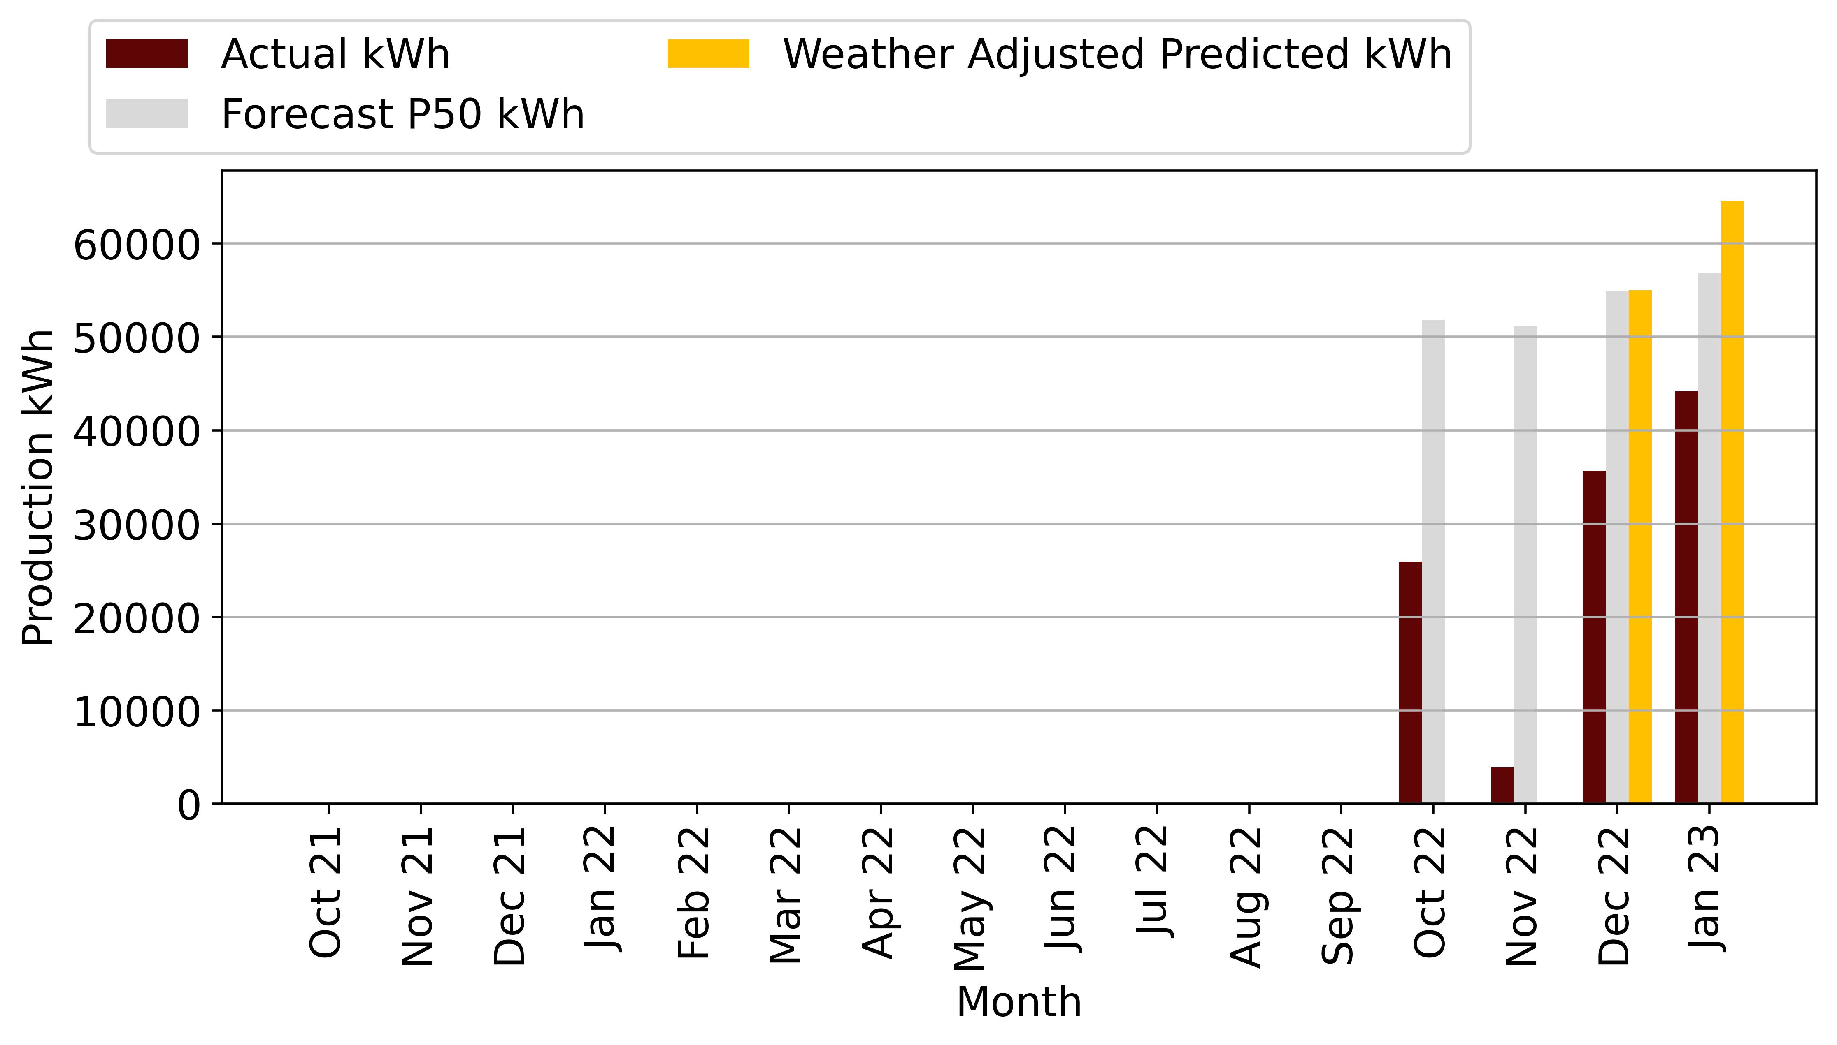

Figure 8‑1: Tzaneen Production Vs Forecast

Total production since COD is 840,969 kWh with a variance of 5.22 % below the original forecast and 4.99 % below the weather adjusted forecast.

The weather-adjusted generation is less than the P50 forecast, which means that the power plant could not exceed the P50 generation.

As the irradiation is low due to cloudy weather conditions since COD. The impact of load shedding is minimal. We have also considered the impact of inverters operating above guaranteed temperature range, as described below.

The following figure describes the inverter temperature at Tzaneen. The thermal image was taken on 30 March 2022, and shows that the inverter is operating at 50 ˚C, which is close to the maximum operating temperature of 60 ˚C. The high operating temperature of the inverter has implications for production. Harmattan notes that the inverter has not exceeded the maximum temperature of 60 ˚C but points out that this could change during the summer months.

Harmattan notes that the Operator (Aces) has proposed that Mediclinic provide additional ventilation to the room where the inverters are located. This has not been done because the winter season has allowed for additional cooling of the inverter.

Harmattan recommends that the Operator provide Mediclinic with a specification for the required cooling of the equipment and conduct further thermal testing at the other sites. Harmattan will review the specification and costing provided by ACES.

# Events

## Health and Safety

No health and safety incidences were reported based on the information provided by the Operator.

## Scheduled Maintenance

Harmattan notes that the operator has only submitted the inspection list for Durbanville, Hermanus and Vergelegen. No problems were noted for Hermanus and Vergelegen. At Durbanville, we noted that nearby trees were shading the panels. The operator did not provide recent reports indicating whether this problem has been corrected.

At Hermanus and Durbanville, module cleaning has not been performed since COD because the modules were clean. For Vergelegen, module cleaning was performed on March 31, 2022. The latest status from the operator is that the modules are still clean. Midstream did module cleaning last month, but during the site visit it was determined that the modules were clean.

## Unscheduled Maintenance

The following table describes the unscheduled maintenance activities that have occurred since COD.

|  |  |  |  |  |
| --- | --- | --- | --- | --- |
| **Date Occurred** | **Plant** | **Events** | **Description** | **Resolution** |
|  |  |  |  |  |
|  |  |  |  |  |
|  |  |  |  |  |
|  |  |  |  |  |
|  |  |  |  |  |
|  |  |  |  |  |

Table 9‑1: Unscheduled Maintenance Events

## Spare Parts

Harmattan notes that no spare parts are kept parts on site. The Operator has stated that minor spare parts are in stock in Cape Town and Johannesburg. Major spares will be kept in Cape Town. We note that only keeping the major spare parts in Cape Town may present a problem for plants outside of Cape Town given the longer lead times to deliver the spare to site, resulting in higher production losses

# Documents Reviewed

|  |  |
| --- | --- |
| **Project Name** | **Documents Reviewed** |
| Vergelegen |  |
| Durbanville |  |
| Midstream |  |
| Hermanus |  |
| Highveldf |  |